TABLE OF CONTENTS
Sr. No. | Contents | Page No.
1 | Certificate | i
2 | Declaration | ii
3 | Acknowledgement | iii
4 | Abstract | iv
5 | List of Figures | v
6 | List of Tables | vi
7 | List of Abbreviations | vii

Chapter 1: Introduction
Sr. No. | Contents | Page No.
1.1 | Introduction | 1
1.2 | Background of the Project | 3
1.3 | Problem Statement | 4
1.4 | Objectives of the Project | 4
1.5 | Scope of the Project | 5
1.6 | Motivation | 6
1.7 | Organization of the Report | 86
Chapter 2: Literature Review
Sr. No. | Contents | Page No.
2.1 | Introduction | 8
2.2 | Existing Vehicle Tracking Systems | 8
2.3 | Existing Stolen Vehicle Detection Methods | 11
2.4 | Vehicle Toll Data Analysis | 13
2.5 | AI-Based Route Prediction Techniques | 15
2.6 | Online Marketplace Monitoring | 17
2.7 | Research Gap | 21
Chapter 3: System Analysis and Requirements
Sr. No. | Contents | Page No.
3.1 | Existing System | 23
3.2 | Limitations of the Existing System | 24
3.3 | Proposed System | 25
3.4 | Advantages of the Proposed System | 27
3.5 | Functional Requirements | 28
3.6 | Non-Functional Requirements | 29
3.7 | Hardware Requirements | 30
3.8 | Software Requirements | 31
Chapter 4: System Design and Architecture
Sr. No. | Contents | Page No.
4.1 | System Architecture | 34
4.2 | System Workflow | 37
4.3 | Data Flow Diagram (DFD) | 38
4.4 | Use Case Diagram | 39
4.5 | Entity Relationship (ER) Diagram | 40
4.6 | Database Design | 44
4.7 | Module Description | 45
4.7.1 | User Authentication and Role Management | 46
4.7.2 | Vehicle Registration and Database Management | 46
4.7.3 | Stolen Vehicle Management | 46
4.7.4 | Toll Transaction Processing | 46
4.7.5 | AI-Based Next-Toll Prediction | 46
4.7.6 | Online Parts-Market Detection | 46
4.7.7 | Vehicle-Part Matching and Risk Analysis | 46
4.7.8 | Alert Generation and Authorized Dashboard | 47
4.7.9 | Reports and Audit Logs | 47
4.8 | Module Design | 48
4.9 | Security Design | 48

Chapter 5: Methodology and Implementation
Sr. No. | Contents | Page No.
5.1 | Project Methodology | 49
5.2 | Data Collection and Dataset Preparation | 49
5.3 | Data Preprocessing | 49
5.4 | Toll Sequence Feature Extraction | 49
5.5 | Random Forest for Next-Toll Prediction | 49
5.6 | Text Preprocessing for Marketplace Listings | 50
5.7 | TF-IDF Feature Extraction | 50
5.8 | Logistic Regression for Listing Classification | 50
5.9 | Vehicle-Part Matching and Risk Scoring | 50
5.10 | Alert Generation Mechanism | 50
5.11 | System Integration | 50
Chapter 6: System Development and Technologies
Sr. No. | Contents | Page No.
6.1 | Development Environment | 52
6.2 | Frontend Development | 52
6.3 | Backend Development | 57
6.4 | Database Implementation | 57
6.5 | Machine Learning Implementation | 57
6.6 | Dashboard and Visualization | 58
6.7 | Security and Access Control | 58
Chapter 7: Testing and Results
Sr. No. | Contents | Page No.
7.1 | Testing Methodology | 59
7.2 | Unit Testing | 59
7.3 | Integration Testing | 60
7.4 | System Testing | 61
7.5 | Test Cases and Results | 61
7.6 | Random Forest Model Evaluation | 61
7.7 | Marketplace Classification Evaluation | 61
7.8 | Dashboard and Alert Results | 62
7.9 | Discussion of Results | 62
Chapter 8: Conclusion and Future Scope
Sr. No. | Contents | Page No.
8.1 | Conclusion | 63
8.2 | Project Limitations | 64
8.3 | Future Enhancements | 65
Chapter 9
Sr. No. | Contents | Page No.
1 | References | 71
Chapter 10
Sr. No. | Contents | Page No.
1 | Appendices | 72
2 | Appendix A | 72
3 | Appendix B | 73
4 | Appendix C | 74

Abstract
The increasing number of vehicles and growing complexity of vehicle theft investigations have created a need for efficient and intelligent vehicle monitoring systems. Investigating stolen vehicles often requires examining vehicle registration records, toll transaction histories, theft reports, and online marketplace listings. Managing this information across different sources can be time-consuming. To address this issue, the proposed project, “AI-Based Stolen Vehicle Toll Tracking and Parts-Market Detection System,” aims to develop an integrated application combining vehicle data management, toll tracking, machine learning, Natural Language Processing (NLP), and automated alert generation.
The system maintains a centralized database containing vehicle details, stolen-vehicle reports, toll transactions, marketplace listings, predictions, alerts, and audit logs. Authorized users can register vehicles, manage stolen-vehicle reports, and monitor recorded toll transactions. By comparing vehicle registration numbers in toll records with active stolen-vehicle reports, the system identifies matching events and generates alerts. Unlike GPS tracking, toll-based tracking provides location information only at recorded toll plazas.
The AI component uses two machine-learning approaches. A Random Forest Classifier predicts the probable next toll plaza using historical toll transaction sequences and relevant features such as previous toll locations and transaction timestamps. For marketplace analysis, Natural Language Processing is applied to listing titles and descriptions. Text is converted into numerical features using TF-IDF, followed by a Logistic Regression classifier to categorize listings and identify potentially relevant vehicle-part information.
The system also includes vehicle and part attribute matching to compare details such as vehicle make, model, part name, and listing description. Risk analysis helps prioritize potential matches for human review. The authorized dashboard displays vehicle information, toll history, prediction results, marketplace classifications, and alerts. Reporting and audit-log features maintain records of important system activities.
The application can be developed using Python, Streamlit, SQLite, and scikit-learn. Synthetic datasets may be used for development and testing when authorized real-world data is unavailable. The machine-learning models should be evaluated using appropriate performance measures such as accuracy, precision, recall, F1-score, and confusion matrices.
The proposed system aims to provide a centralized decision-support platform that assists authorized personnel in analyzing toll records and marketplace listings during stolen-vehicle investigations. It demonstrates the practical use of artificial intelligence, data analysis, and automated alerts while ensuring that predictions and potential matches are verified by authorized personnel before any conclusions are drawn.

LIST OF FIGURES

Figure No. | Figure Description | Page no.
3.1 | Proposed System Architecture | 27
4.1 | System Architecture Diagram | 34
4.2 | System Workflow Diagram | ___
4.3 | Data Flow Diagram – Level 0 | ___
4.4 | Data Flow Diagram – Level 1 | ___
4.5 | Entity Relationship (ER) Diagram | 42

LIST OF TABLES

Table No. | Table Description | Page No.
3.1 | Functional Requirements | ___
3.2 | Non-Functional Requirements | ___
3.3 | Hardware Requirements | ___
3.4 | Software Requirements | ___
4.1 | DFD Level 1 Process Description | ___
4.2 | Use Case Description | ___
4.3 | Vehicle Table Structure | ___
4.4 | Stolen Report Table Structure | ___
4.5 | Toll Transaction Table Structure | ___
4.6 | Marketplace Listing Table Structure | ___
4.7 | Alert Table Structure | ___
7.1 | Functional Test Cases and Results | ___
7.2 | Random Forest Model Evaluation | ___
7.3 | Marketplace Classification Evaluation | ___

LIST OF ABBREVIATIONS
Abbreviation | Full Form
AI | Artificial Intelligence
ML | Machine Learning
NLP | Natural Language Processing
GPS | Global Positioning System
RF | Random Forest
TF-IDF | Term Frequency–Inverse Document Frequency
LR | Logistic Regression
DFD | Data Flow Diagram
ER | Entity Relationship
DBMS | Database Management System
SQL | Structured Query Language
UI | User Interface
PK | Primary Key
FK | Foreign Key
CSV | Comma-Separated Values
API | Application Programming Interface
IDE | Integrated Development Environment

CHAPTER 1 -
Introduction
In the modern world, vehicles have become an essential part of daily life, providing convenient transportation for individuals, businesses, and public services. With the increasing number of vehicles on roads, vehicle security and the prevention of vehicle theft have become important concerns. Vehicle theft can cause financial losses to owners, create difficulties for investigating authorities, and contribute to the illegal resale of stolen vehicles and vehicle components. Therefore, there is a need for efficient systems that can organize vehicle-related information, monitor available vehicle movement records, and support the identification of potentially relevant information during investigations.
Traditional stolen-vehicle investigation processes may involve checking vehicle registration records, examining theft reports, reviewing toll transaction histories, and searching online marketplaces for vehicle parts. When these sources are maintained separately, collecting and comparing information can be time-consuming. Manual analysis may also make it difficult to identify patterns across large datasets. An integrated software system can help address these challenges by centralizing relevant information and providing tools for automated data processing, analysis, and reporting.
The project “AI-Based Stolen Vehicle Toll Tracking and Parts-Market Detection System” proposes an integrated application that combines vehicle record management, toll-based vehicle tracking, machine learning, Natural Language Processing (NLP), and alert generation. The primary objective is to assist authorized users in reviewing toll events associated with reported stolen vehicles and identifying marketplace listings that may be relevant to vehicle-part investigations.
The system maintains a centralized database containing vehicle details, stolen-vehicle reports, toll transactions, marketplace listings, alerts, and audit records. Authorized users can register vehicles, maintain stolen reports, search records, review toll histories, and monitor alerts. When toll transaction data is imported from an authorized source, the system compares the recorded vehicle registration number with the active stolen-vehicle database. If a matching record is identified, the system generates an alert containing relevant information for further review.
Unlike GPS-based tracking, which can provide location coordinates at regular intervals when a suitable device is available, toll-based tracking relies on recorded vehicle passages at participating toll plazas. These observations provide information about where and when a vehicle was recorded at a toll plaza. By organizing multiple transactions chronologically, the system can construct an observed toll sequence and use historical patterns to estimate the probable next toll plaza. However, toll-based tracking does not provide continuous real-time location information between toll plazas.
Artificial Intelligence (AI) and Machine Learning (ML) form an important part of the proposed system. The first AI component uses a Random Forest Classifier to predict the probable next toll plaza from historical toll transaction sequences. The model learns relationships between input features, such as previous toll plaza, current toll plaza, time of passage, time interval, and available route information, and the next observed toll plaza. The resulting prediction can help authorized users examine possible route patterns. The prediction is probabilistic and cannot guarantee the vehicle's actual future route.
The second AI component focuses on marketplace listing analysis using Natural Language Processing. Online marketplace listings often contain textual descriptions of vehicle parts, including product names, vehicle models, part numbers, and other identifying information. Manually examining large numbers of listings can be difficult. To support this task, the proposed system uses TF-IDF (Term Frequency–Inverse Document Frequency) to convert listing text into numerical features. These features are processed by a Logistic Regression classifier, which learns to categorize listings according to the labels provided in the training dataset. Vehicle and part attributes can then be compared to prioritize potentially relevant listings for authorized review.
The system also includes a risk-analysis and alert-generation mechanism. The risk or matching score is based on available evidence, such as classification results and vehicle-part attribute similarities. When defined conditions are satisfied, an alert is created for review by an authorized user. The dashboard presents relevant vehicle records, toll transaction history, next-toll predictions, marketplace analysis results, and alerts through a single interface. Reporting and audit-log functions help maintain a record of important operations and status changes.
The proposed application can be developed using Python, Streamlit, a database such as SQLite, and machine-learning libraries such as scikit-learn. Its modular architecture separates the user interface, database operations, data preprocessing, machine-learning components, and reporting functions. If real toll or marketplace datasets are unavailable, clearly labeled synthetic data can be used for development and functional testing. Real-world use requires appropriate authorization to access the relevant data sources.
The project is intended as a decision-support system rather than a replacement for official investigation procedures. A registration-number match, route prediction, or marketplace classification does not independently establish criminal activity. The accuracy and usefulness of the system depend on the quality of the available data, the representativeness of the training datasets, the reliability of classification labels, and proper model evaluation. Human verification remains necessary before any consequential decision is made.
Overall, the project demonstrates how database management, machine learning, NLP, and software development can be combined to address a practical vehicle-security problem. By integrating toll-event analysis, probable next-toll prediction, marketplace listing classification, vehicle-part matching, and alert management, the system aims to provide a structured and efficient platform for reviewing potentially relevant vehicle-related information.
1.2 Background of the Project
Vehicle theft is a problem that requires the coordination of vehicle owners, authorized agencies, vehicle databases, and other relevant information sources. When a vehicle is reported stolen, investigators may need to examine available records to understand its observed movement and identify information that could assist the investigation.
Technological developments have made it possible to collect and analyze different types of vehicle-related information. Electronic toll collection systems generate transaction records when vehicles pass through participating toll plazas. These records can provide time-stamped observations that may be organized into a sequence for historical analysis. Machine-learning techniques can use such sequences to learn patterns and estimate probable future toll events.
At the same time, online marketplaces contain large volumes of listings for vehicle components. These listings are usually represented as text and may describe parts using different terms, abbreviations, or vehicle-model names. NLP techniques can help convert this unstructured text into a form that machine-learning algorithms can analyze.
The proposed project combines these two areas in a single application. Toll transaction analysis supports stolen-vehicle monitoring and next-toll prediction, while marketplace text classification supports the identification of potentially relevant vehicle-part listings. A centralized database and dashboard connect these functions and allow authorized users to review the resulting information.
The project therefore provides an opportunity to apply Python programming, database management, data preprocessing, supervised machine learning, NLP, and web application development to an integrated academic project.
1.3 Problem Statement
The identification and investigation of stolen vehicles may require the examination of multiple information sources, including vehicle registration records, theft reports, toll transactions, and online marketplace listings. When these sources are handled independently, collecting and comparing relevant information can require substantial manual effort.
Conventional database searches can identify exact matches, but they do not automatically learn patterns from historical toll sequences or classify marketplace descriptions using trained machine-learning models. Furthermore, the lack of an integrated interface can make it difficult to maintain a consolidated history of vehicle records, toll events, marketplace findings, and alerts.
Therefore, the problem addressed by this project is the development of a centralized, AI-assisted system that supports stolen-vehicle monitoring through authorized toll transaction records, predicts probable next toll locations from historical data, classifies marketplace listings using NLP, and generates alerts for further review.
The system aims to improve the organization and analysis of vehicle-related information while maintaining appropriate access controls, audit records, and human oversight.
1.4 Objectives of the Project
The main objectives of the project are:
- To develop a centralized database for storing vehicle details and stolen-vehicle reports.
- To provide authorized users with functions for vehicle registration, record searching, and status management.
- To import and process authorized toll transaction data.
- To identify toll events that match vehicles with active stolen reports.
- To develop a Random Forest classification model for predicting the probable next toll plaza from historical toll sequences.
- To apply NLP techniques for analyzing marketplace listing descriptions.
- To use TF-IDF for text feature extraction and Logistic Regression for marketplace listing classification.
- To compare vehicle and part attributes to identify potentially relevant marketplace listings.
- To generate alerts for toll-event matches and marketplace findings that require review.
- To provide a dashboard for viewing vehicle information, toll histories, predictions, and alerts.
- To maintain reports and audit logs for important system operations.
- To evaluate system functionality and AI model performance using suitable test datasets and evaluation metrics.
1.5 Scope of the Project
The scope of the project includes the design and development of a software application that integrates vehicle record management, stolen-vehicle reporting, toll transaction processing, next-toll prediction, marketplace listing classification, alert generation, and report management.
The application supports the storage and retrieval of vehicle information and provides a mechanism for comparing toll transactions against active stolen-vehicle reports. It also incorporates a machine-learning pipeline for next-toll prediction and an NLP pipeline for marketplace listing classification.
The project includes a dashboard through which authorized users can examine relevant records and review generated alerts. Database and audit functions help maintain the history of important operations.
The initial implementation can use synthetic datasets to demonstrate data processing, model training, prediction, and classification when authorized real-world data is unavailable. The synthetic data must be clearly identified and must not be represented as actual toll-agency or law-enforcement records.
The project does not provide continuous GPS tracking, independently verify criminal activity, or guarantee the future route of a vehicle. Integration with actual toll systems, official registration databases, or online marketplaces depends on authorization and the availability of permitted data interfaces.
1.6 Motivation
The motivation for developing this project comes from the need to explore how artificial intelligence can support the analysis of vehicle-related information.
Manual examination of separate datasets can be difficult when records are numerous or contain inconsistent information. Machine learning provides methods for identifying patterns in historical observations, while NLP provides methods for analyzing unstructured textual data. Combining these methods with a centralized database can create a more organized workflow for reviewing vehicle records and potentially relevant marketplace listings.
From an academic perspective, the project provides practical experience in several areas of information technology, including Python programming, database design, data preprocessing, supervised machine learning, text classification, web application development, testing, and reporting.
The project also demonstrates an important distinction between traditional software functions and AI-based functions. Vehicle registration, database searching, user authentication, and fixed-condition alert generation are conventional software operations. Random Forest-based next-toll prediction and TF-IDF with Logistic Regression for marketplace classification are the components that introduce trained machine-learning capabilities.
The project is motivated by the opportunity to integrate these technologies into a single application while considering data reliability, privacy, security, and the need for human review.
1.7 Organization of the Report
The project report is organized into eight chapters.
- Chapter 1: Introduction describes the project background, problem statement, objectives, scope, motivation, and overall purpose.
- Chapter 2: Literature Review discusses existing vehicle tracking methods, stolen-vehicle detection, toll transaction analysis, route prediction, marketplace monitoring, and the research gap.
- Chapter 3: System Analysis and Requirements explains the existing system, proposed system, functional requirements, non-functional requirements, and hardware and software requirements.
- Chapter 4: System Design and Architecture presents the system architecture, workflow, data-flow diagrams, use-case diagram, ER diagram, database design, and module descriptions.
- Chapter 5: Methodology and Implementation describes data collection, preprocessing, toll sequence feature extraction, Random Forest prediction, TF-IDF, Logistic Regression, vehicle-part matching, and alert generation.
- Chapter 6: System Development and Technologies explains the development environment, programming language, user interface, backend, database, AI implementation, dashboard, and security mechanisms.
- Chapter 7: Testing and Results describes the testing strategy, test cases, model evaluation metrics, application outputs, and discussion of the measured results.
- Chapter 8: Conclusion and Future Scope summarizes the project, discusses its limitations, and presents possible future improvements.

CHAPTER 2 -
Literature Review
A literature review is an important part of a research project because it provides an understanding of existing systems, technologies, research methods, and approaches related to the proposed work. It helps identify the limitations of existing solutions and the areas where improvements can be made.
Vehicle theft is a significant concern because stolen vehicles may be transported across different locations, sold illegally, or dismantled into individual parts. Traditional stolen vehicle detection systems generally depend on police records, vehicle registration databases, manual investigation, and information reported by vehicle owners. Although these methods are useful, they may not always provide timely information about a vehicle's movement or the possible sale of its parts through online marketplaces.
Advances in Artificial Intelligence (AI), Machine Learning (ML), Natural Language Processing (NLP), and data analytics provide opportunities to improve vehicle theft investigation. Toll transaction records can help identify the sequence of toll plazas crossed by a vehicle, while machine learning can analyze historical movement patterns to estimate a possible next toll plaza. Similarly, NLP techniques can analyze online marketplace descriptions to identify listings that may be related to vehicle parts.
The proposed AI-Based Stolen Vehicle Toll Tracking and Parts-Market Detection System combines toll transaction analysis, machine learning-based next-toll prediction, marketplace listing classification, and alert generation in one centralized system. This chapter reviews the existing approaches and technologies relevant to the proposed system and identifies the research gap addressed by the project.
2.2 Existing Vehicle Tracking Systems
Vehicle tracking systems are used to monitor vehicle movement, location, and travel history. They are commonly applied in fleet management, logistics, transportation, and vehicle security.

2.2.1 GPS-Based Vehicle Tracking
Global Positioning System (GPS) technology determines a device's geographical location using satellite signals. A GPS-based vehicle tracking system typically consists of a GPS receiver, a communication network, a data-processing application, and a user interface.
The location information collected by a GPS device can be transmitted to a server, where it can be stored and displayed on a digital map. Authorized users can view the vehicle's reported position and movement history.
Advantages:
- Provides geographical location information.
- Supports route visualization and travel-history analysis.
- Can help monitor vehicle movement when a functioning tracking device is available.
Limitations:
- Requires a suitable tracking device or access to authorized location data.
- Tracking quality depends on device availability, signal conditions, and connectivity.
- Historical location data may be unavailable if the device was not recording.
- GPS tracking is different from toll tracking because GPS can provide location observations at frequent intervals, whereas toll records provide observations at specific toll plazas.
In the proposed project, toll transaction analysis is considered the primary method for studying vehicle movement rather than continuous GPS tracking.
2.2.2 Vehicle Registration Databases
Vehicle registration databases maintain information about registered vehicles. Depending on the database and the user's authorization, records may include registration numbers, vehicle categories, manufacturers, models, registration dates, and registration status.
Such databases can support the identification of a vehicle by its registration number and help authorized personnel verify vehicle details.

Advantages:
- Provides structured vehicle information.
- Supports vehicle identification and record verification.
- Helps maintain a centralized record of reported stolen and recovered vehicles.
- Can be integrated with other authorized data sources.
Limitations:
- Registration data alone does not show a vehicle's current location.
- Information may not reflect the latest status unless updated.
- Access to real vehicle records may be restricted by privacy and legal requirements.
- A registration database does not independently predict future vehicle movement.
The proposed system uses vehicle records as a reference for matching toll transactions with reported stolen vehicles. For academic development, synthetic vehicle records may be used where authorized real records are unavailable.
2.2.3 Toll-Based Vehicle Tracking
Electronic toll collection systems record vehicle passage at designated toll plazas. Depending on the toll system, a transaction may contain information such as a vehicle identifier, toll plaza identifier, transaction date and time, and transaction status.
When authorized toll records are available, a sequence of transactions can be used to reconstruct the observed order in which a vehicle passed different toll plazas.
For example, a sequence such as Toll Plaza A, Toll Plaza B, and Toll Plaza C indicates observed passage through these locations in that order. The sequence can be analyzed to identify common movement patterns and estimate a possible next toll plaza.
Advantages:
- Provides time-stamped observations at participating toll plazas.
- Supports historical toll-sequence analysis.
- Can help investigators narrow down possible travel corridors.
- Provides structured records suitable for database processing and machine learning.
Limitations:
- Toll data does not provide continuous vehicle location.
- A vehicle may travel on roads without passing a recorded toll plaza.
- Missing, delayed, or inaccurate transactions may affect analysis.
- Predictions depend on the availability and quality of historical records.
- Access to identifiable toll records requires appropriate authorization.
Therefore, toll-based analysis should be treated as a method of identifying observed passages and estimating possible movement, rather than as continuous real-time tracking.
2.3 Existing Stolen Vehicle Detection Methods
Stolen vehicle detection involves identifying vehicles reported as stolen and helping authorized personnel investigate their possible movement or recovery.
2.3.1 Manual Verification
In a manual verification system, investigators check vehicle registration details against available records. They may also examine complaints, transaction histories, and other relevant evidence.
Advantages:
- Allows investigators to use contextual knowledge.
- Supports verification of unusual or incomplete records.
- Can be useful when data is limited.
Limitations:
- Requires considerable manual effort.
- Processing large numbers of records may take time.
- Results can depend on the availability of accurate information.
- Manual comparison may overlook relationships across multiple datasets.
The proposed system aims to assist this process through automated searching, matching, and alert generation.
2.3.2 Rule-Based Stolen Vehicle Detection
Rule-based systems apply predefined conditions to identify records requiring attention. For example, if a vehicle registration number associated with an active stolen report appears in an authorized toll transaction, the system can generate an alert.
This is a simplified representation of an exact-match rule. A practical implementation should also handle invalid records, duplicate transactions, uncertain matches, and updated vehicle status.
Advantages:
- Simple to implement and understand.
- Produces predictable results.
- Works well when identification fields are accurate.
- Does not require model training for exact-match detection.
Limitations:
- Depends on predefined conditions.
- Cannot independently predict an unobserved future toll passage.
- May fail when identifiers are missing or inconsistent.
- Does not automatically identify complex patterns in historical data.
The proposed system retains rule-based matching for direct stolen-vehicle alerts and uses machine learning for separate prediction and classification tasks.
2.3.3 Database-Based Detection
Database-based detection uses structured tables to store vehicle information, stolen reports, toll transactions, marketplace listings, and alerts. Queries can retrieve relevant records and compare information across tables.
For example, a database query can identify toll transactions associated with vehicles whose status is marked as stolen.
Advantages:
- Supports efficient searching and filtering.
- Maintains structured records.
- Enables reporting and historical analysis.
- Provides a foundation for integrating multiple modules.
Limitations:
- Database queries alone do not learn movement patterns.
- Results depend on data accuracy and completeness.
- Unstructured marketplace descriptions require additional text-processing techniques.
A centralized database is therefore an important component of the proposed system, but it must be combined with suitable analytical methods to provide more advanced functionality.
2.4 Vehicle Toll Data Analysis
Toll data analysis involves examining transactions collected at toll plazas to understand observed vehicle movement patterns. It may include organizing transactions by time, identifying the order of toll plazas, calculating time intervals, and identifying repeated sequences.
2.4.1 Toll Transaction Records
A toll transaction dataset may contain the following fields:
Field | Description
Transaction ID | Unique identifier for a toll transaction
Vehicle ID | Identifier used to associate the record with a vehicle
Toll Plaza ID | Identifier of the toll plaza
Transaction Date | Date of the recorded passage
Transaction Time | Time of the recorded passage
Transaction Status | Status of the transaction, where available
The precise fields depend on the source system. Synthetic data can be created for development and testing, but it should be clearly labeled and should not be presented as actual toll records.
2.4.2 Toll Sequence Construction
For movement analysis, transactions are grouped by vehicle identifier and arranged in chronological order.
For example:
Vehicle ID | Time | Toll Plaza
V101 | 09:00 | T01
V101 | 09:42 | T03
V101 | 10:25 | T05
V101 | 11:10 | T07

This sequence can be used as an input for a next-toll prediction model. The model learns from historical examples of previous toll sequences and their subsequent recorded toll plazas.
The sequence alone does not prove that the vehicle followed a particular road between toll plazas. It represents the order of available observations.
2.4.3 Toll Data Preprocessing
Raw transaction data may contain missing values, duplicate records, inconsistent identifiers, or invalid timestamps. Preprocessing improves the quality of data used for analysis.
The main preprocessing operations include:
- Removing or reviewing duplicate transactions.
- Checking required fields for missing values.
- Standardizing toll plaza and vehicle identifiers.
- Converting timestamps into a consistent format.
- Sorting transactions chronologically.
- Checking for impossible or inconsistent time sequences.
- Separating training and testing records without leaking future information into the training data.
Accurate preprocessing is essential because errors in transaction sequences can lead to incorrect predictions.
2.4.4 Importance of Toll Data Analysis
Toll data analysis can support investigations by highlighting the latest observed toll passage, identifying repeated travel patterns, and estimating likely next toll plazas. However, predictions must be interpreted carefully.
A predicted toll plaza is a candidate for further investigation, not confirmation that the vehicle will pass there. The system should present the prediction alongside its timestamp, supporting historical observations, and any limitations in the available data.
2.5 AI-Based Route and Next-Toll Prediction Techniques
Artificial Intelligence and Machine Learning techniques allow systems to identify patterns from historical data. In this project, the prediction task is defined as estimating the next likely toll plaza based on previously observed toll transactions.
2.5.1 Machine Learning for Movement Prediction
Movement prediction models use historical observations to estimate a future location, destination, route segment, or movement category. The choice of model depends on the data format, prediction objective, and amount of available training data.
For toll-based prediction, each historical example can contain features derived from earlier transactions, while the target is the toll plaza recorded next in chronological order.
Potential input features include:
- Previous toll plaza.
- Earlier toll plazas in the sequence.
- Time of the previous transaction.
- Time interval between consecutive toll transactions.
- Day of the week, if relevant and available.
- Historical transition patterns.
The model should be trained using historical examples that reflect the intended prediction task.
2.5.2 Random Forest Classifier
Random Forest is a supervised machine learning algorithm that combines predictions from multiple decision trees. It can be used for classification and regression tasks.
For this project, a Random Forest Classifier is suitable as a candidate model because the next toll plaza is a categorical target. The model can learn relationships between toll-sequence features and the next observed toll plaza.
The basic workflow is:
- Collect and validate historical toll transactions.
- Arrange transactions chronologically for each vehicle.
- Create training examples from earlier toll observations.
- Extract relevant features from each example.
- Assign the next recorded toll plaza as the target label.
- Train the Random Forest Classifier.
- Evaluate predictions using held-out historical data.
- Use the trained model to generate candidate next-toll predictions.
The model combines predictions from multiple trees to produce a final class prediction. Depending on the implementation, it may also provide class probabilities that can be used to rank candidate toll plazas.
Advantages of Random Forest:
- Supports classification using multiple input features.
- Can model nonlinear relationships.
- Combines multiple decision trees.
- Is available through widely used machine learning libraries such as scikit-learn.
Limitations:
- Requires representative training data.
- Performance may decrease when travel patterns change.
- Predictions may be unreliable for rarely observed toll plazas.
- It does not automatically understand physical road connectivity unless suitable features or constraints are included.
- A high model score does not guarantee that a predicted passage will occur.
For fair evaluation, historical data should be divided chronologically where appropriate. This reduces the risk of using future transactions to predict earlier events.
2.5.3 Evaluation of Next-Toll Prediction
The Random Forest Classifier should be evaluated against a held-out test set. Relevant evaluation measures include:
- Top-1 accuracy: the proportion of test cases where the highest-ranked prediction matches the actual next toll plaza.
- Top-k accuracy: the proportion of test cases where the actual next toll plaza appears among the top \(k\) predicted candidates.
- Confusion matrix: a summary of actual versus predicted toll-plaza classes.
- Baseline comparison: comparison with a simple method, such as predicting the most frequent next toll plaza from the training data.
These metrics help determine whether the model performs better than a simple baseline. Actual results should be reported only after the model has been trained and tested.
2.6 Online Marketplace Monitoring and Parts Detection
Online marketplaces allow users and businesses to publish descriptions of vehicles, accessories, and spare parts. These listings may contain useful information, but the text can vary considerably in format and detail.
For example, a listing might describe a headlamp, side mirror, bumper, engine component, or other vehicle part. A marketplace detection system can analyze listing text to identify items that may be relevant to a vehicle under investigation.
The purpose of this module is to prioritize potentially relevant listings for authorized human review. A text classifier cannot independently establish that a listing contains stolen property.
2.6.1 Challenges in Marketplace Data
Marketplace descriptions can present several challenges:
- Different sellers use different names for the same component.
- Descriptions may contain spelling errors or abbreviations.
- Vehicle make and model details may be missing.
- Listings may include unrelated words or promotional content.
- Duplicate listings may appear on the same or different platforms.
- A listing may be legitimate even when its description matches a vehicle under investigation.
Therefore, marketplace detection requires careful text preprocessing and evaluation.
2.6.2 Natural Language Processing
Natural Language Processing (NLP) is a field of AI that enables computers to process and analyze human language. Text classification is an NLP task in which a model assigns a category to a piece of text.
In the proposed system, NLP can be used to classify marketplace listing descriptions into predefined categories, such as:
- Relevant vehicle-part listing.
- General or unrelated listing.
The categories must be defined clearly and supported by appropriately labeled training examples. The model's output indicates a predicted category, not the legal status of the item being sold.

2.6.3 Text Preprocessing
Before training a text classification model, listing descriptions are processed to make them more consistent.
Typical steps include:
- Converting text into a consistent case.
- Removing unnecessary spaces and formatting artifacts.
- Handling missing descriptions.
- Standardizing common terms where appropriate.
- Combining relevant fields, such as listing title and description.
- Checking and removing duplicate records when necessary.
Preprocessing decisions should be selected according to the dataset. For example, removing all numbers may be inappropriate because vehicle models, part numbers, and model years can be useful features.
2.6.4 TF-IDF Feature Extraction
Term Frequency–Inverse Document Frequency (TF-IDF) is a statistical technique used to convert text into numerical features. It assigns weights to terms according to their frequency in a document and how common they are across the collection of documents.
TF-IDF converts textual descriptions into numerical vectors that can be processed by a machine learning classifier.
Advantages:
- Provides a simple numerical representation of text.
- Can highlight terms that are informative within a dataset.
- Works with conventional machine learning algorithms.
- Is suitable for many small and medium-sized text classification tasks.
Limitations:
- Does not fully understand the meaning or context of a sentence.
- May not recognize synonyms unless the training data or preprocessing accounts for them.
- Can be affected by spelling variations and limited training examples.
- Does not independently determine whether a listed item is stolen.
2.6.5 Logistic Regression for Listing Classification
Logistic Regression is a supervised learning algorithm commonly used for classification. Although its name includes the word “regression,” it can estimate the probability of a sample belonging to a class.
In the proposed system, the text of each marketplace listing is converted into TF-IDF features. These features are then provided to a Logistic Regression classifier trained on labeled examples.
The workflow is:
- Collect marketplace listing text from an authorized source or create a labeled synthetic dataset.
- Assign each listing a predefined class.
- Clean and preprocess the text.
- Convert the text into TF-IDF vectors.
- Train the Logistic Regression model.
- Classify new listing descriptions.
- Send potentially relevant results for further attribute matching and human review.
Advantages:
- Provides a straightforward classification method.
- Works well with sparse numerical text features in many applications.
- Supports probability estimates when configured appropriately.
- Is relatively efficient to train and use.

Limitations:
- Depends on the quality and representativeness of labeled data.
- May perform poorly on unfamiliar terminology or changing marketplace language.
- Can produce false-positive and false-negative classifications.
- Requires evaluation on data that was not used during training.
2.7 Research Gap
The reviewed approaches provide useful capabilities for vehicle identification, movement analysis, and marketplace text classification. However, each approach has limitations when used independently.
GPS-based systems may offer detailed location information, but they depend on suitable tracking devices and access to location data. Registration databases provide vehicle information but do not independently describe a vehicle's movement. Rule-based systems can detect exact matches but generally do not learn movement patterns from historical toll sequences. Marketplace search and manual investigation can identify potentially relevant listings, but processing a large number of descriptions may require substantial effort.
The proposed project addresses these challenges by combining several complementary functions:
- Centralized vehicle and stolen-report management: stores structured vehicle details and the status of reported stolen vehicles.
- Toll transaction analysis: organizes available toll records chronologically to identify observed toll passages.
- Next-toll prediction: applies a Random Forest Classifier to estimate likely next toll plazas from historical toll-sequence features.
- Marketplace text classification: applies TF-IDF and Logistic Regression to identify listings that may be relevant to vehicle-part investigations.
- Vehicle and part matching: compares available identifiers and attributes to prioritize potentially relevant records.
- Alert generation and dashboard: presents matching records, predictions, and potentially relevant listings to authorized users.
- Audit and reporting: maintains records of system activity and supports investigation review.
The main contribution is the integration of toll-sequence prediction and marketplace text classification with conventional stolen-vehicle record matching in a single system. The system is designed to support investigation, not to replace human judgment or establish criminal activity automatically.

CHAPTER 3 -
System Analysis and Requirement
System analysis is an important phase of software development in which the existing system is studied, its limitations are identified, and the requirements of the proposed system are defined. It helps determine how the proposed application can solve the identified problem using suitable technologies and methods.
The AI-Based Stolen Vehicle Toll Tracking and Parts-Market Detection System is designed to assist authorized users in managing stolen vehicle records, analyzing toll transaction data, predicting possible next toll plazas, and identifying potentially relevant vehicle-part listings from online marketplaces.
The proposed system integrates conventional database operations with machine learning and Natural Language Processing (NLP). A Random Forest Classifier is used for next-toll prediction, while TF-IDF and Logistic Regression are used for marketplace listing classification. The system also provides vehicle matching, alert generation, reporting, and audit logging.
This chapter describes the existing system, its limitations, the proposed system, its advantages, functional and non-functional requirements, and the hardware and software requirements.
3.2 Existing System
Existing stolen vehicle investigation methods commonly use vehicle registration records, police reports, manual verification, and available vehicle movement information. Investigators may check whether a vehicle has been reported stolen and examine records collected from relevant sources.
In some systems, GPS devices are used to monitor vehicle location. However, GPS tracking requires suitable devices and access to location information. Another approach is to analyze toll transactions, which provide records of a vehicle passing through particular toll plazas at specific times.
Online marketplace investigations may involve searching listing titles and descriptions manually to identify potentially relevant vehicle parts. This process can become time-consuming when many listings are available.
The major components of conventional approaches are described below.
3.2.1 Manual Vehicle Verification
Manual verification involves comparing a vehicle's registration number and other details with available stolen vehicle records. Investigators may review reports and update the vehicle's status when new information becomes available.
Although this method is useful, it requires human effort and may become inefficient when the number of records increases.
3.2.2 Database-Based Vehicle Management
Database-based systems store vehicle details, stolen reports, and related records in structured tables. Users can search for vehicles and retrieve information through database queries.
However, a basic database system does not automatically learn historical movement patterns or classify marketplace descriptions using machine learning.
3.2.3 Toll Record Analysis
Toll records can provide evidence that a vehicle passed a participating toll plaza at a particular time. Investigators can examine the sequence of toll transactions to understand the observed movement of a vehicle.
Traditional manual analysis may require users to review multiple transactions and compare them with existing reports. A machine learning model can be used to estimate a possible next toll plaza based on historical sequences, provided sufficient suitable data is available.
3.2.4 Manual Marketplace Searching
Investigators may search online marketplaces using vehicle models, spare-part names, or other relevant keywords. This method can identify some potentially relevant listings but may miss descriptions that use alternative terminology.
An NLP-based classifier can help categorize listing descriptions and prioritize those that require additional review.
3.3 Limitations of the Existing System
The existing approaches have several limitations that motivate the development of the proposed system.
- Manual effort: Checking multiple vehicle records, toll transactions, and marketplace listings can take considerable time.
- Limited integration: Vehicle records, toll data, and marketplace listings may be maintained separately.
- Lack of predictive analysis: Basic record-management systems do not predict a possible next toll plaza from historical movement patterns.
- Keyword limitations: Simple keyword searches may not identify relevant listings that use different terms or descriptions.
- Delayed identification: Relevant information may remain unnoticed when records are not reviewed promptly.
- Data-quality issues: Missing, duplicate, inconsistent, or outdated records can affect the reliability of analysis.
- Limited centralized reporting: Separate systems may make it difficult to generate a consolidated view of relevant records.
- False matches: Similar vehicle or part descriptions may be unrelated to a reported stolen vehicle.
- Privacy and access concerns: Vehicle and toll records may contain sensitive information and require appropriate authorization.
- Lack of explainability: A prediction without supporting information may be difficult for an investigator to interpret.
The proposed system addresses these limitations through centralized record management, automated matching, machine learning-based prediction, NLP-based classification, and human-reviewed alerts.
3.4 Proposed System
The proposed system is a centralized application that integrates vehicle registration management, stolen vehicle reporting, toll transaction analysis, AI-based next-toll prediction, marketplace listing classification, and alert generation.
The system maintains vehicle records and active stolen reports in a database. When authorized toll transaction data is imported, the system processes the records and compares vehicle identifiers with active stolen vehicle reports. If a match is found, the system can generate an alert for authorized review.
Historical toll sequences are used to train a Random Forest Classifier to estimate a possible next toll plaza. The prediction is based on available historical observations and does not represent continuous GPS tracking.
For marketplace detection, listing titles and descriptions are preprocessed and converted into TF-IDF vectors. A Logistic Regression classifier categorizes the listings according to predefined training labels. The system can then compare relevant listing attributes with available vehicle or part information and prioritize potential matches.
The system provides a dashboard through which authorized users can view vehicle records, stolen reports, toll transactions, model predictions, marketplace listings, alerts, and reports.
3.4.1 Working of the Proposed System
The proposed system follows these steps:
- User authentication: The user logs in using valid credentials.
- Vehicle registration: Vehicle details are added to the database.
- Stolen vehicle reporting: Authorized users record stolen vehicle reports and maintain their status.
- Toll data input: Authorized or synthetic toll transaction records are imported.
- Data preprocessing: Records are checked for missing values, duplicates, invalid timestamps, and inconsistent identifiers.
- Next-toll prediction: The Random Forest Classifier estimates a possible next toll plaza using historical toll-sequence features.
- Listing classification: TF-IDF and Logistic Regression classify the listing text.
- Alert generation: Potential matches and relevant predictions are presented for authorized review.
- Dashboard and reporting: Users review results, generate reports, and consult available audit records.

3.4.2 Proposed System Architecture
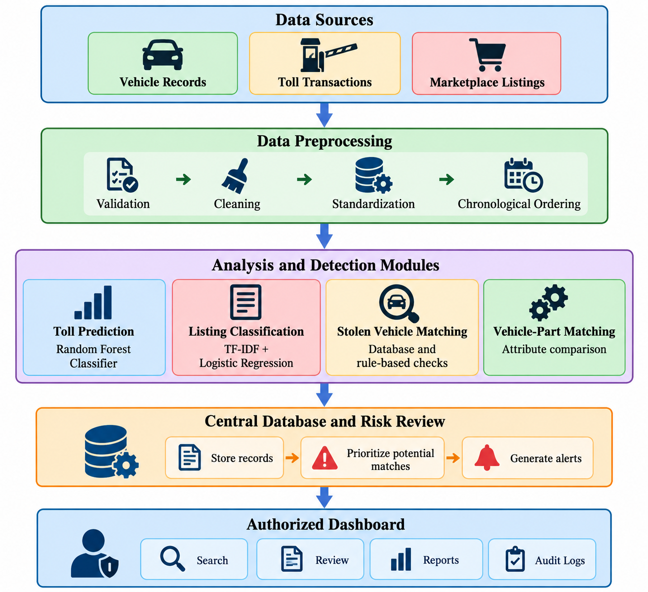Figure 3.1: Proposed system architecture.
This is a conceptual architecture; ensure the final diagram matches the modules actually implemented in the application.
3.5 Advantages of the Proposed System
The proposed system offers the following advantages:
- Centralized information: Vehicle records, stolen reports, toll transactions, and marketplace listings can be managed in one application.
- Automated matching: Toll transactions can be compared automatically with active stolen vehicle reports.
- Predictive capability: The Random Forest Classifier can estimate possible next toll plazas from historical sequences.
- Text classification: TF-IDF and Logistic Regression can classify marketplace listing descriptions.
- Improved investigation support: Relevant records can be organized and prioritized for review.
- Alert generation: Potential matches can be brought to the attention of authorized users.
- Historical record management: Stored transactions and audit logs can support later review.
- Report generation: Consolidated reports can reduce the effort required to collect information from separate modules.
- Modular design: Individual components can be tested and improved independently.
These advantages describe the intended capabilities of the proposed design. Actual performance and operational benefits must be confirmed through implementation and testing.
3.6 Functional Requirements
Functional requirements describe the operations the system must perform.
Requirement ID | Functional requirement | Description
FR-01 | User authentication | Allow registered users to log in securely.
FR-02 | Role management | Restrict sensitive functions to authorized roles.
FR-03 | Vehicle registration | Add, view, search, and update vehicle records.
FR-04 | Stolen vehicle management | Record stolen reports and update vehicle status.
FR-05 | Toll data import | Import toll transactions from a supported dataset.
FR-06 | Toll data preprocessing | Validate, clean, and organize toll transactions.
FR-07 | Vehicle matching | Compare toll transaction identifiers with active stolen reports.
FR-08 | Next-toll prediction | Use a trained Random Forest Classifier to predict candidate next toll plazas.
FR-09 | Marketplace data import | Load marketplace listing information.
FR-10 | Listing classification | Classify listing text using TF-IDF and Logistic Regression.
FR-11 | Vehicle-part matching | Compare relevant listing attributes with vehicle or part records.
FR-12 | Alert management | Generate and display potential matches for review.
FR-13 | Dashboard | Display summary information and relevant records.
FR-14 | Report generation | Generate reports from available system records.
FR-15 | Audit logging | Record important user and system activities.
Note: These are the target functional requirements. Requirements that have not yet been implemented should be treated as planned functionality rather than completed features.
3.7 Non-Functional Requirements
Non-functional requirements describe the expected quality, security, usability, and performance of the system.
3.7.1 Performance
The application should process normal-sized datasets within a reasonable time. Database queries, model inference, and dashboard operations should remain responsive under the expected workload.
Performance should be measured during testing instead of assuming that a particular speed has already been achieved.
3.7.2 Security
The system should protect sensitive records from unauthorized access. Passwords should be stored using an appropriate password-hashing method, and role-based access should restrict access to sensitive operations.

3.7.3 Reliability
The system should handle invalid input without crashing and should report meaningful errors when data cannot be processed. Important database operations should preserve data consistency.
3.7.4 Usability
The interface should provide clear navigation, readable tables, understandable alerts, and useful error messages. Users should be able to find important records without needing advanced technical knowledge.
3.7.5 Maintainability
The application should use modular code, meaningful names, and clear separation between user-interface logic, database operations, and machine learning components.
3.7.6 Scalability
The system should be designed so that its data-processing and database components can be improved as the number of vehicles, transactions, and marketplace listings increases.
3.7.7 Accuracy
The prediction and classification models should be evaluated using suitable metrics and independent test data. The system should clearly distinguish predicted results from confirmed records.
3.7.8 Privacy and Legal Compliance
Vehicle registration information, toll records, and marketplace data must be obtained and processed only where authorized. Sensitive data should be protected, and the system should not treat a model prediction as proof of wrongdoing.
3.8 Hardware Requirements
The following hardware specifications are suggested for academic development and testing. Actual requirements depend on dataset size and model complexity.

Component | Minimum suggested configuration | Recommended configuration
Processor | Dual-core processor | Modern Intel Core i5 or equivalent
RAM | 4 GB | 8 GB or more
Storage | 5 GB free space | 10 GB or more free space
Display | Standard laptop display | Full HD display
Network | Internet access for installation and authorized data retrieval | Stable internet connection
The system does not require a dedicated GPU for basic development using tabular data, Random Forest, TF-IDF, and Logistic Regression.
3.9 Software Requirements
The following software can be used to implement the proposed system.
Software/Technology | Purpose
Python | Main programming language
Visual Studio Code | Code editing and project development
Streamlit | Web-based application interface
SQLite or MySQL | Storage of vehicle, toll, listing, and alert records
Pandas | Data loading, cleaning, and preprocessing
NumPy | Numerical operations
scikit-learn | Random Forest, TF-IDF, Logistic Regression, and model evaluation
Matplotlib or Plotly | Data visualization, where required
Git and GitHub | Version control and source-code management
Web browser | Accessing and testing the application
The final report should list the technologies actually used in the submitted project. For example, if the current application uses SQLite, SQLite should be described as the implemented database rather than claiming that MySQL is already integrated.

3.10 Feasibility Study
A feasibility study determines whether the proposed system can reasonably be developed and operated.
3.10.1 Technical Feasibility
The system can be developed using commonly available technologies such as Python, Streamlit, Pandas, scikit-learn, and a relational database. These technologies support data processing, web-based interfaces, machine learning, and record management.
The major technical challenge is obtaining sufficiently representative toll transaction sequences and labeled marketplace listings. Synthetic datasets can support initial development and functional testing, but they cannot establish real-world predictive performance.
3.10.2 Economic Feasibility
The system can be developed using open-source software, which reduces licensing expenses. Development can be carried out on a standard personal computer.
Additional expenses may arise if the project requires paid hosting, commercial datasets, or authorized access to external services. The total cost depends on the final deployment approach.
3.10.3 Operational Feasibility
A dashboard-based interface can help authorized users search records, inspect alerts, and review reports. Basic training and documentation should be provided so users understand how to interpret the outputs.
Human review remains necessary because predicted toll passages and marketplace matches may be incorrect.
3.10.4 Schedule Feasibility
The project can be divided into manageable phases: requirements analysis, database design, data preparation, model development, interface development, integration, testing, and documentation.
A modular implementation allows each phase to be developed and tested before the complete system is evaluated.
3.11 System Constraints and Assumptions
The proposed system operates under the following constraints and assumptions:
- Toll transaction data must be available in a supported format.
- Vehicle identifiers must be sufficiently consistent for meaningful matching.
- Historical toll sequences must be available to train and evaluate the next-toll prediction model.
- Marketplace listings must be labeled appropriately for supervised text classification.
- External data access must comply with applicable laws, privacy rules, and service terms.
- Synthetic data may be used during development when authorized real data is unavailable.
- Predictions may be inaccurate when data is sparse, outdated, or unrepresentative.
- A toll record indicates an observed passage at a particular plaza; it does not provide continuous GPS tracking.
- Potential marketplace matches require additional investigation.
- System results support authorized decision-making but do not independently establish criminal activity.

CHAPTER 4 -
System Design and Architecture
System design is an important phase of software development. It describes the structure of the proposed system, its major components, the flow of data, and the relationships between different modules.
The proposed system is designed to manage stolen vehicle records, analyze toll transactions, predict possible next toll plazas, and identify potentially relevant vehicle-part listings from online marketplaces. It combines database management with Artificial Intelligence (AI) and Natural Language Processing (NLP).
The system uses a Random Forest Classifier for next-toll prediction and TF-IDF with Logistic Regression for marketplace listing classification. It also includes vehicle matching, alert generation, a dashboard, and reporting.
This chapter explains the system architecture, workflow, data flow diagrams, use case design, database design, and major modules of the application.
4.2 System Architecture
The system follows a modular architecture. Each module performs a specific task and communicates with other modules through shared data and processing functions.
The architecture contains five major layers.
4.2.1 Data Sources
The system uses three main categories of data.
1. Vehicle Records
Vehicle records contain details such as:
- Vehicle registration number
- Vehicle make and model
- Vehicle type
- Vehicle color
These records help identify vehicles and maintain information about reported stolen vehicles.
2. Toll Transactions
Toll transaction records may contain:
- Transaction ID
- Vehicle identifier
- Transaction date and time
These records are used to identify observed toll passages and construct historical toll sequences.
3. Marketplace Listings
Marketplace data contains listing titles, descriptions, part names, and available vehicle attributes. This information is processed to identify listings that may be relevant to vehicle-part investigations.
Data should be obtained through authorized sources. Synthetic data may be used for development and testing when real data is unavailable.
4.2.2 Data Preprocessing
Data preprocessing prepares input records for analysis.
The main operations include:
- Checking required fields.
- Handling missing values.
- Removing or reviewing duplicate records.
- Standardizing vehicle and toll identifiers.
- Converting date and time fields into a consistent format.
- Sorting toll transactions chronologically.
- Cleaning marketplace listing text.
Preprocessing improves data consistency and reduces errors during analysis.
4.2.3 Analysis and Detection Modules
This layer contains four major modules.
Toll Prediction: Uses a Random Forest Classifier to estimate a possible next toll plaza from historical toll-sequence features.
Listing Classification: Uses TF-IDF to convert listing text into numerical features and Logistic Regression to classify the text.
Stolen Vehicle Matching: Compares toll transaction identifiers with vehicle records and active stolen reports using database queries and predefined rules.
Vehicle-Part Matching: Compares available listing attributes, such as vehicle make, model, and part name, to prioritize potentially relevant listings.
4.2.4 Central Database and Risk Review
The database stores vehicle information, stolen reports, toll transactions, marketplace listings, predictions, alerts, and audit records. The risk-review component organizes potential matches for further investigation. Any risk score should be based on clearly defined criteria and must not be treated as proof of criminal activity.
4.2.5 Authorized Dashboard
The dashboard provides an interface for authorized users to:
- Search vehicle records.
- View stolen vehicle reports.
- Review toll transactions.
- View next-toll predictions.
- Review alerts.
- Generate reports.
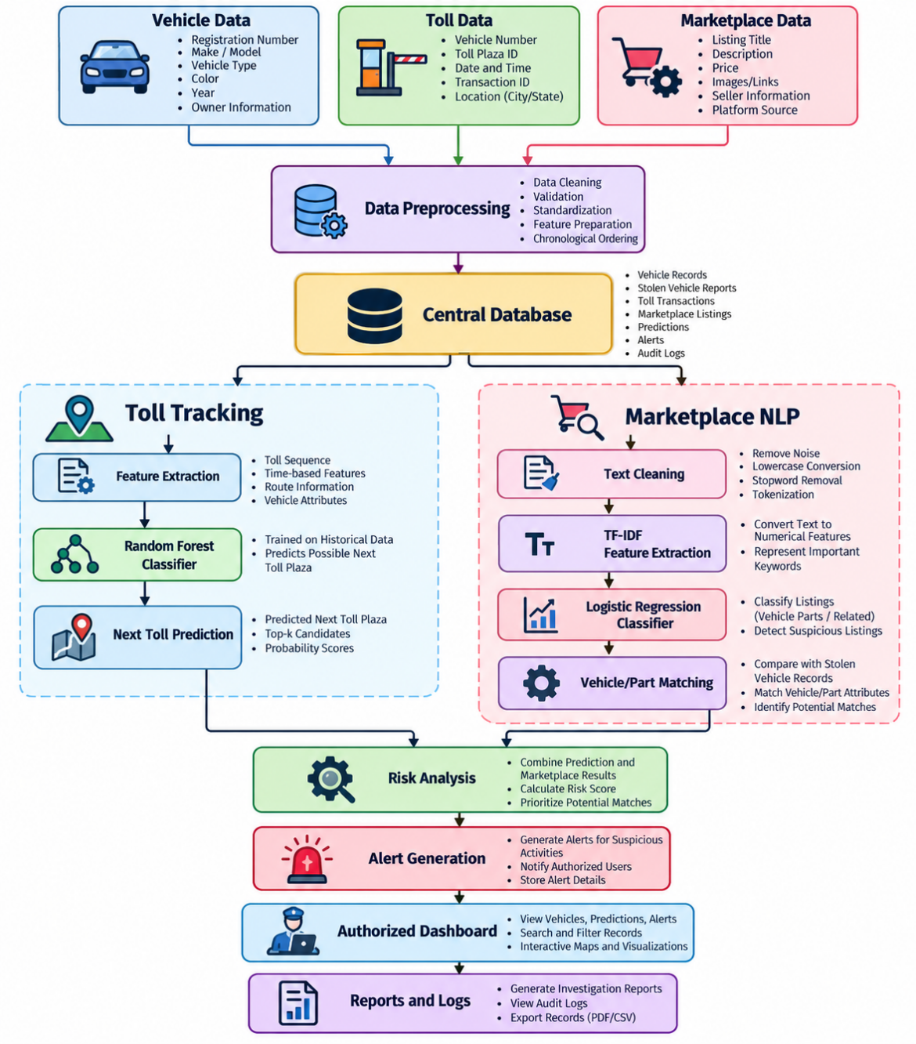
Figure 4.1: System architecture diagram
4.3 System Workflow
The system workflow describes how information moves from data input to final results.
The proposed workflow consists of the following steps:
- User login: The user enters valid credentials to access the application.
- Vehicle registration: Vehicle details are stored in the database.
- Stolen report management: Authorized users record stolen vehicle reports and update their status.
- Toll data import: Toll transaction records are imported into the system.
- Data preprocessing: The system validates records, checks duplicates, standardizes identifiers, and arranges transactions chronologically.
- Stolen vehicle matching: Toll transactions are compared with active stolen vehicle records.
- Next-toll prediction: The Random Forest Classifier predicts a possible next toll plaza from historical transaction sequences.
- Marketplace data import: Listing titles and descriptions are loaded into the application.
- Text classification: TF-IDF and Logistic Regression are used to classify listing descriptions.
- Vehicle-part matching: Available listing attributes are compared with relevant vehicle or part details.
- Alert generation: Potential matches are presented for authorized review.
- Dashboard display: Users view records, predictions, alerts, and reports.
- Audit logging: Important actions are recorded where audit logging is implemented.
The output of the system supports investigation and review. A predicted toll plaza represents an estimate based on historical data, not a confirmed current location.
4.4 Data Flow Diagram (DFD)
A Data Flow Diagram represents how information moves between external entities, processes, and data stores.
4.4.1 DFD Level 0
Level 0 represents the entire application as a single process.
The main external entities are:
- Authorized User: Provides vehicle information, manages stolen reports, and requests reports.
- Vehicle and Toll Data Sources: Supply available vehicle and transaction records.
- Marketplace Data Source: Supplies listing information for classification.
The central process is the AI-Based Stolen Vehicle Toll Tracking and Parts-Market Detection System.
The system receives input data, processes the information, and returns results such as predictions, potential matches, alerts, and reports.
4.4.2 DFD Level 1
Level 1 divides the system into smaller processes.
Process ID | Process | Input | Output
P1 | Authentication | Login credentials | Access decision
P2 | Vehicle management | Vehicle details | Vehicle records
P3 | Stolen vehicle management | Stolen report details | Stolen reports
P4 | Toll data processing | Toll transactions | Validated transactions
P5 | Next-toll prediction | Historical toll sequences | Predicted toll candidates
P6 | Marketplace classification | Listing text | Predicted listing category
P7 | Vehicle-part matching | Vehicle and listing attributes | Potential matches
P8 | Alert management | Matching results | Alerts and review status
P9 | Reporting | Stored system records | Reports
The processes use the central database to store and retrieve relevant information.
4.5 Use Case Design
A use case describes a function performed by a user through the system.
4.5.1 Actors
Administrator: Manages authorized user accounts, assigns roles, and performs permitted system-management tasks.
Authorized Investigator or User: Searches vehicle records, reviews stolen reports, imports data, views predictions, examines marketplace matches, and generates reports.
4.5.2 Main Use Cases
Use case | Description
Login | Verifies user credentials.
Manage users | Creates or updates authorized accounts.
Register vehicle | Adds vehicle details to the database.
Manage stolen report | Records or updates a stolen vehicle report.
Import toll data | Loads transaction records.
Analyze toll data | Prepares chronological toll sequences.
Predict next toll | Estimates a possible next toll plaza.
Import marketplace listings | Loads listing descriptions and attributes.
Classify listing | Predicts the category of a listing.
Match vehicle parts | Compares available vehicle and part attributes.
Review alerts | Displays potential matches for investigation.
Generate report | Produces a summary of available records.
View audit logs | Displays recorded system activities.
4.5.3 Use Case Relationships
The administrator and authorized investigator share the login function. The administrator has additional user-management permissions. The investigator uses the vehicle, toll, marketplace, and reporting functions according to assigned access rights.
4.6 Entity Relationship (ER) Design
An Entity Relationship (ER) diagram describes the entities stored in the database and the relationships between them.
The proposed system contains eight main entities:
- USER
- VEHICLE
- STOLEN_REPORT
- TOLL_TRANSACTION
- MARKETPLACE_LISTING
- PREDICTION
- ALERT
- AUDIT_LOG
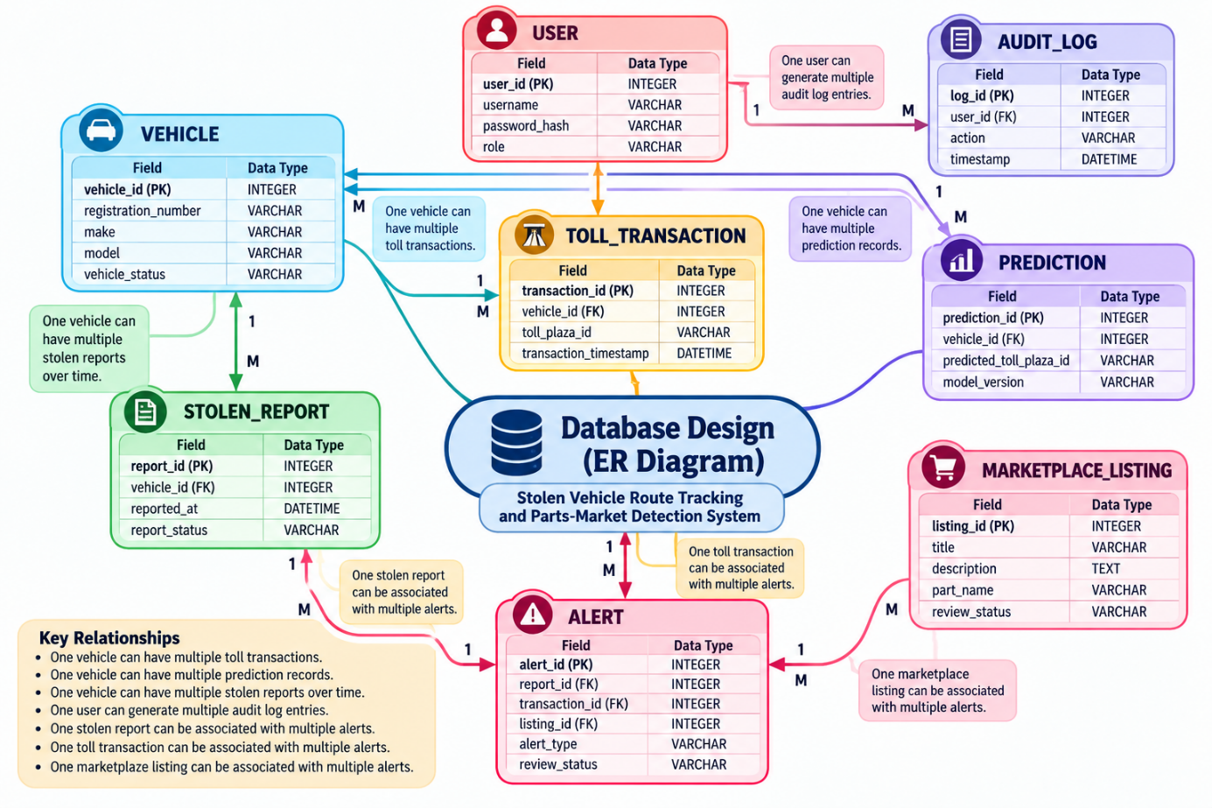
4.6.1 Entity Descriptions
1. USER
Stores the details of authorized users.
- user_id: Primary key
- username: Login name
- password_hash: Hashed password
- role: User role
2. VEHICLE
Stores vehicle identification information.
- vehicle_id: Primary key
- registration_number: Vehicle registration number
- make: Manufacturer
- model: Vehicle model
- vehicle_status: Current status
3. STOLEN_REPORT
Stores reports associated with stolen vehicles.
- report_id: Primary key
- vehicle_id: Foreign key
- reported_at: Report date and time
- report_status: Current report status
4. TOLL_TRANSACTION
Stores toll transaction information.
- transaction_id: Primary key
- vehicle_id: Foreign key, when the vehicle is identified
- toll_plaza_id: Toll plaza identifier
- transaction_timestamp: Transaction date and time

5. MARKETPLACE_LISTING
Stores marketplace listing information.
- listing_id: Primary key
- title: Listing title
- description: Listing description
- part_name: Vehicle part name
- review_status: Review status
6. PREDICTION
Stores next-toll prediction results.
- prediction_id: Primary key
- vehicle_id: Foreign key, when applicable
- predicted_toll_plaza_id: Predicted toll plaza
- model_version: Model version used
7. ALERT
Stores potential matches that require review.
- alert_id: Primary key
- report_id: Related stolen report
- transaction_id: Related toll transaction
8. AUDIT_LOG
Stores important system activities.
- log_id: Primary key
- user_id: Foreign key
- action: Activity performed
- timestamp: Date and time of activity
4.6.2 Relationships Between Entities
- One vehicle can have multiple toll transactions.
- One vehicle can have multiple prediction records.
- One vehicle can have multiple stolen reports over time.
- One user can generate multiple audit log entries.
- One stolen report can be associated with multiple alerts.
- One toll transaction can be associated with multiple alerts if the system permits different alert types.
- One marketplace listing can be associated with multiple alerts.
The exact relationships should match the implemented database schema.
4.6.3 ER Diagram Representation
Figure 4.5: ER diagram of the proposed system — insert the ER diagram image created in the previous step here.
The diagram shows the entities, primary keys, foreign keys, and relationships between records. It provides a foundation for creating the database tables and maintaining consistency.
4.7 Database Design
The database stores information used by the different system modules. A relational database is suitable because the project contains structured records connected through identifiers.
4.7.1 Vehicle Table
Field | Data type | Purpose
vehicle_id | INTEGER | Primary key
registration_number | VARCHAR | Vehicle identifier
make | VARCHAR | Manufacturer
model | VARCHAR | Vehicle model
vehicle_status | VARCHAR | Vehicle status

4.7.2 Stolen Report Table
Field | Data type | Purpose
report_id | INTEGER | Primary key
vehicle_id | INTEGER | Foreign key
reported_at | DATETIME | Report date
report_status | VARCHAR | Active or closed status
4.7.3 Toll Transaction Table
Field | Data type | Purpose
transaction_id | INTEGER | Primary key
vehicle_id | INTEGER | Vehicle reference
toll_plaza_id | VARCHAR | Toll plaza identifier
transaction_timestamp | DATETIME | Transaction time
4.7.4 Marketplace Listing Table
Field | Data type | Purpose
listing_id | INTEGER | Primary key
title | VARCHAR | Listing title
description | TEXT | Listing description
part_name | VARCHAR | Part name
review_status | VARCHAR | Review state
4.7.5 Alert Table
Field | Data type | Purpose
alert_id | INTEGER | Primary key
report_id | INTEGER | Related stolen report
transaction_id | INTEGER | Related toll transaction
listing_id | INTEGER | Related listing
alert_type | VARCHAR | Alert category
review_status | VARCHAR | Review state
The database can be extended with prediction and audit-log tables. Foreign keys, indexes, and validation rules should be applied where appropriate.
4.8 Module Design
The system is divided into modules to simplify development and testing.
4.8.1 User Authentication Module
This module verifies user credentials and controls access to protected functions. It may include login, logout, and role-based access control.
4.8.2 Vehicle Registration Module
This module allows authorized users to add, search, view, and update vehicle records. It checks required fields and helps prevent duplicate records.
4.8.3 Stolen Vehicle Management Module
This module records stolen vehicle reports and updates their status. It maintains the information required for matching toll transactions with active reports.
4.8.4 Toll Transaction Processing Module
This module imports toll records, validates their fields, handles duplicates, standardizes timestamps, and arranges transactions chronologically.
4.8.5 Next-Toll Prediction Module
This module uses a Random Forest Classifier to estimate a possible next toll plaza from historical toll-sequence features.
Its main operations are:
- Prepare historical transaction sequences.
- Predict candidate next toll plazas.
- Display the prediction for review.
4.8.6 Marketplace Classification Module
This module uses TF-IDF to convert listing descriptions into numerical features. Logistic Regression classifies the text according to the categories defined in the training dataset.
The predicted category is used to prioritize potentially relevant listings, not to establish whether a part is stolen.
4.8.7 Vehicle-Part Matching Module
This module compares listing attributes with available vehicle and part information. It may use make, model, part name, and other available attributes to identify possible matches.
4.8.8 Alert Generation Module
This module creates alerts when predefined matching conditions are met. Examples include a toll transaction matching an active stolen report or a potentially relevant marketplace listing.
Alerts should include the reason for their creation and remain subject to human review.
4.8.9 Dashboard and Reporting Module
This module displays vehicle records, toll history, predictions, marketplace listings, and alerts. It also supports searching, filtering, and generating reports from available information.
4.8.10 Audit Logging Module
This module records important system activities, such as data imports, changes to records, alert reviews, and report generation. Audit logs support accountability and troubleshooting.
4.9 Security Design
The system may process sensitive vehicle and transaction records, so security must be considered during implementation.
The main security measures include:
- Authentication: Require users to log in before accessing protected functions.
- Role-based access control: Restrict sensitive operations to authorized roles.
- Password hashing: Store password hashes rather than plaintext passwords.
- Input validation: Check imported data and user input before processing.
- Data protection: Prevent unauthorized access to sensitive records.
- Audit logging: Record important operations and changes.
- Error handling: Display useful errors without exposing passwords or secrets.
- Privacy protection: Use only authorized data and minimize unnecessary personal information.
- Model transparency: Distinguish model predictions from verified records.
These measures describe the intended security design. Their actual implementation should be verified during testing.

CHAPTER 5 -
Methodology and Implementation
This chapter explains the methodology used to develop the AI-Based Stolen Vehicle Toll Tracking and Parts-Market Detection System. The system combines database management, toll transaction analysis, machine learning, and Natural Language Processing (NLP) to identify potential matches and support vehicle theft investigations.
5.2 Project Methodology
The project follows these major steps:
- Data Collection: Collect vehicle records, toll transactions, and marketplace listings from authorized sources or prepare synthetic datasets.
- Data Preprocessing: Remove duplicate records, handle missing values, standardize fields, and arrange toll transactions chronologically.
- Vehicle Matching: Compare toll transaction identifiers with active stolen vehicle reports.
- Next-Toll Prediction: Use a Random Forest Classifier to predict a possible next toll plaza based on historical toll sequences.
- Marketplace Classification: Apply TF-IDF and Logistic Regression to classify marketplace listing descriptions.
- Alert Generation: Present potential matches for authorized review.
- Testing: Evaluate system functionality and measure model performance using suitable metrics.
5.3 Data Preprocessing
Data preprocessing improves the consistency and quality of the input data.
For toll records, preprocessing includes checking vehicle identifiers, validating timestamps, removing duplicate transactions, and sorting records chronologically.
For marketplace listings, preprocessing includes cleaning text, handling missing descriptions, standardizing terms where appropriate, and preparing labeled examples for model training.
5.4 Random Forest for Next-Toll Prediction
The Random Forest Classifier is used to estimate the next likely toll plaza based on historical toll transactions.
The implementation involves:
- Organizing transactions by vehicle and timestamp.
- Extracting features from previous toll observations.
- Using the next recorded toll plaza as the target class.
- Training the Random Forest Classifier.
- Testing predictions on separate historical data.
- Displaying candidate toll plazas for review.
The model estimates a possible next toll plaza; it does not provide continuous GPS tracking or guarantee the vehicle's future location.
5.5 Marketplace Classification Using TF-IDF and Logistic Regression
The marketplace module analyzes listing titles and descriptions to identify potentially relevant vehicle-part listings.
TF-IDF converts text into numerical features. Logistic Regression then classifies the resulting feature vectors using labeled training data.
The main steps are text preprocessing, TF-IDF feature extraction, model training, model evaluation, and classification of new listings. Classified listings may then be compared with available vehicle and part attributes.
5.6 Vehicle Matching and Alert Generation
The system compares toll transactions with active stolen vehicle reports using database queries and predefined matching rules.
When a potential match is found, the system can generate an alert containing relevant record details. Marketplace listings may also be flagged when their classification and available attributes indicate a potential match.
All alerts require appropriate human review. A match or model prediction alone does not establish that a vehicle or part is stolen.
5.7 System Integration
The different modules are integrated into one application. The database stores vehicle records, stolen reports, toll transactions, marketplace listings, predictions, and alerts.
The dashboard allows authorized users to search records, review predictions, inspect potential matches, and generate reports. Access control and audit logging help protect sensitive information and record important system activities.

CHAPTER 6 –
System Development and Technology
This chapter describes the technologies, software tools, database, and development environment used to develop the proposed system.
6.2 Development Environment
The system can be developed using the following tools:
Software/Tool | Purpose
Python | Main programming language
Visual Studio Code | Writing and managing source code
Streamlit | Developing the web interface
SQLite/MySQL | Storing system records
Pandas | Data processing
scikit-learn | Implementing machine learning models
Web browser | Running and testing the application
6.3 Frontend Development
The frontend provides an interface through which authorized users interact with the system. The interface may contain the following pages:
- Login page
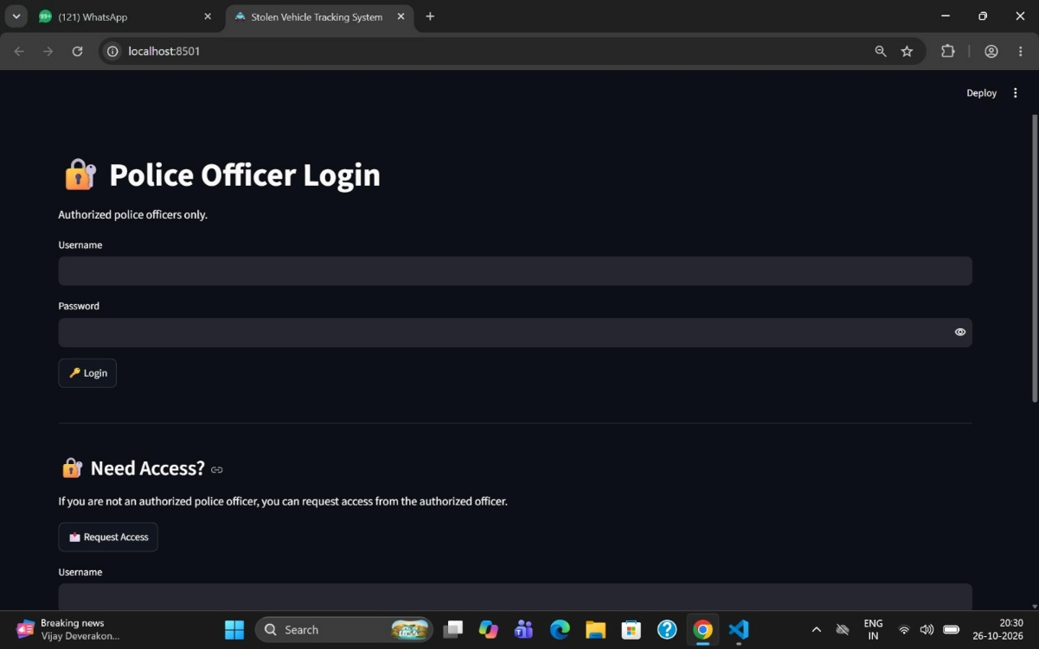
- Dashboard
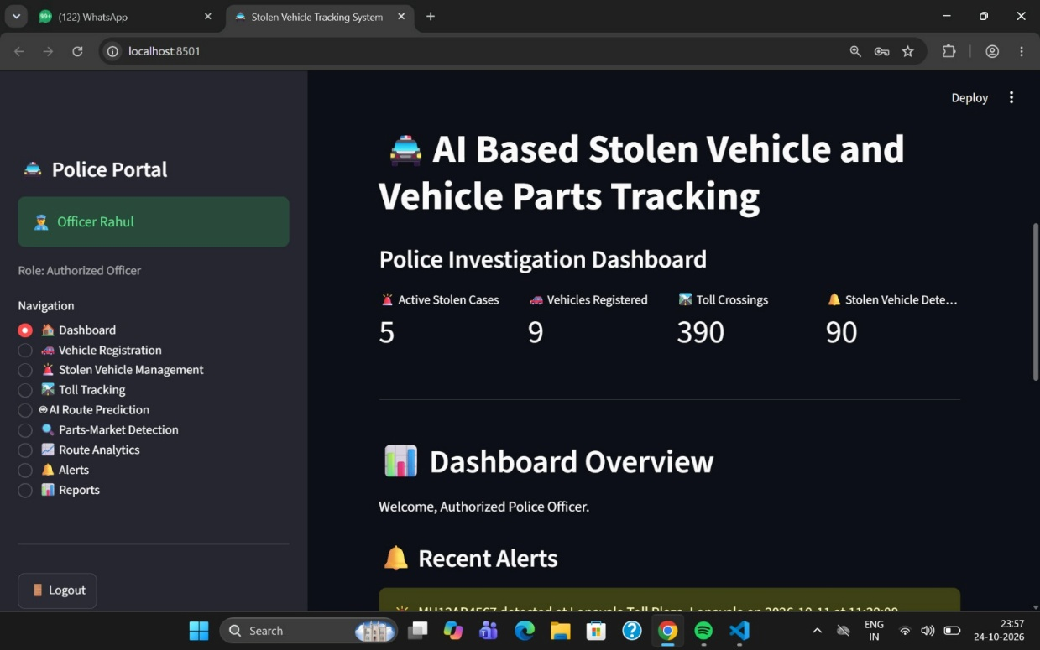

- Vehicle registration
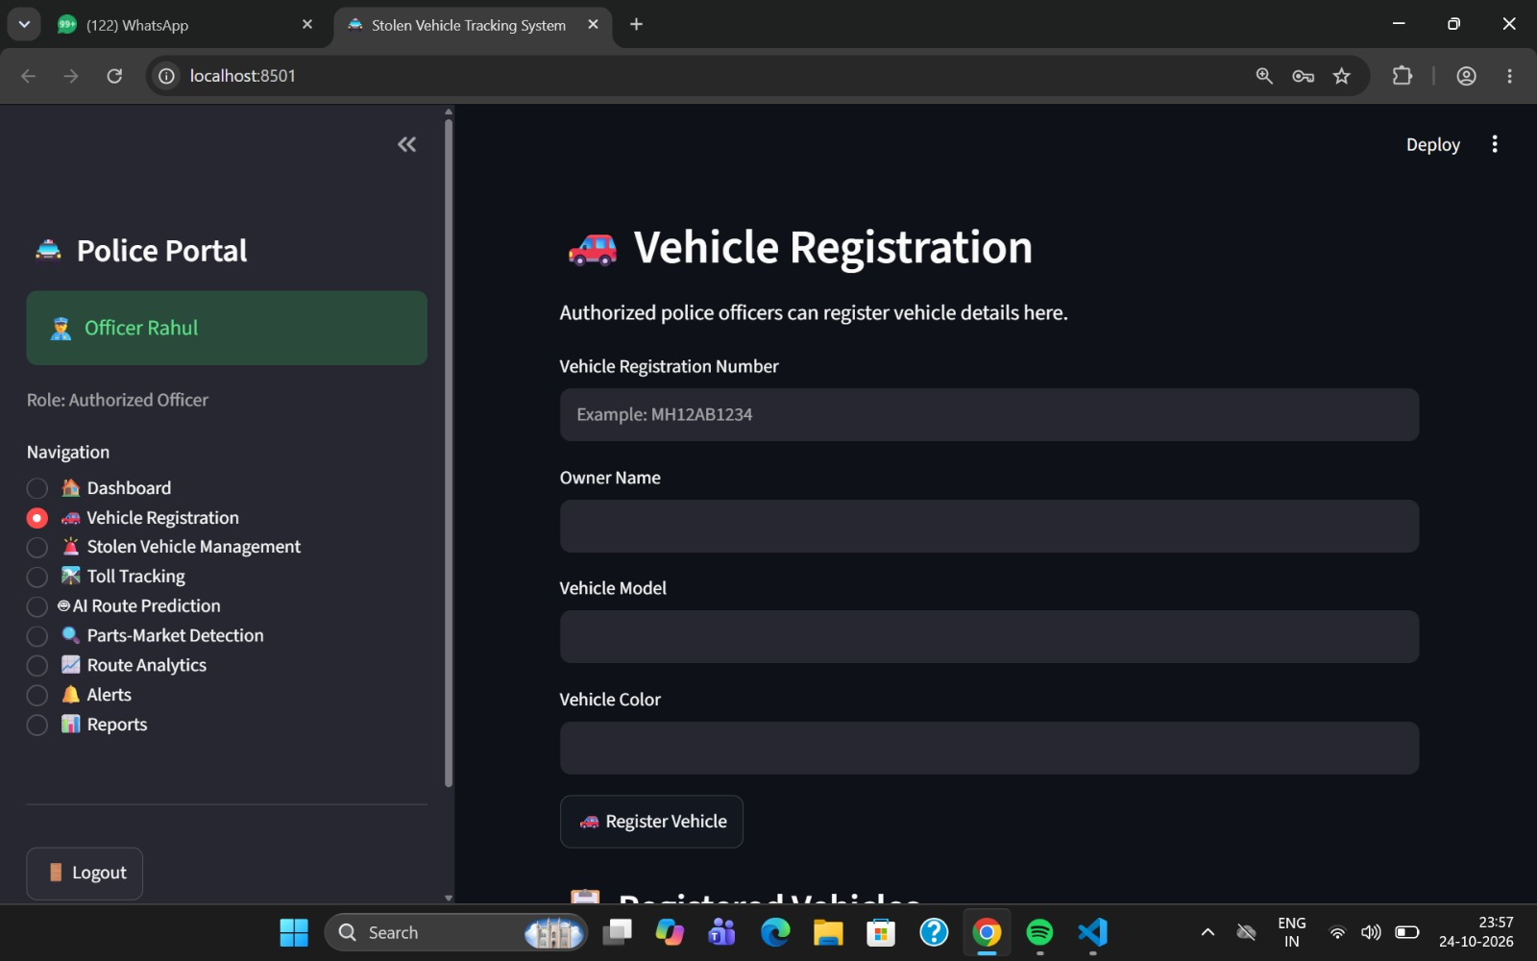

- Stolen vehicle management
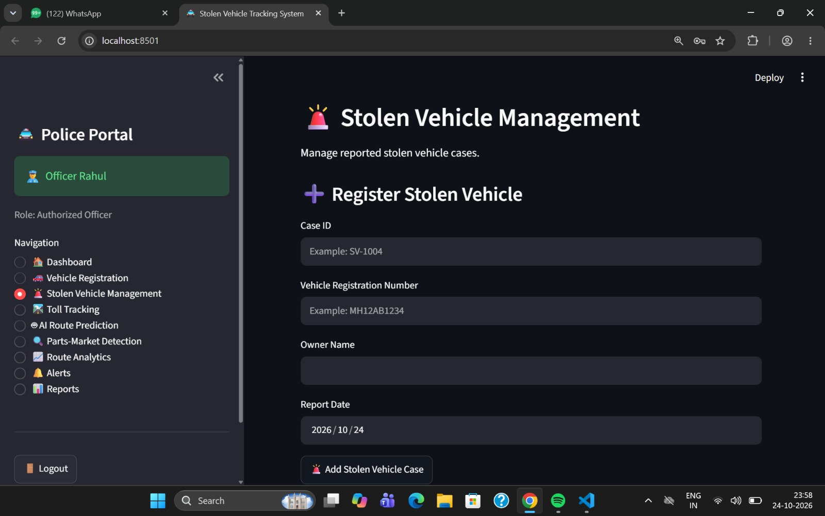

- Toll tracking
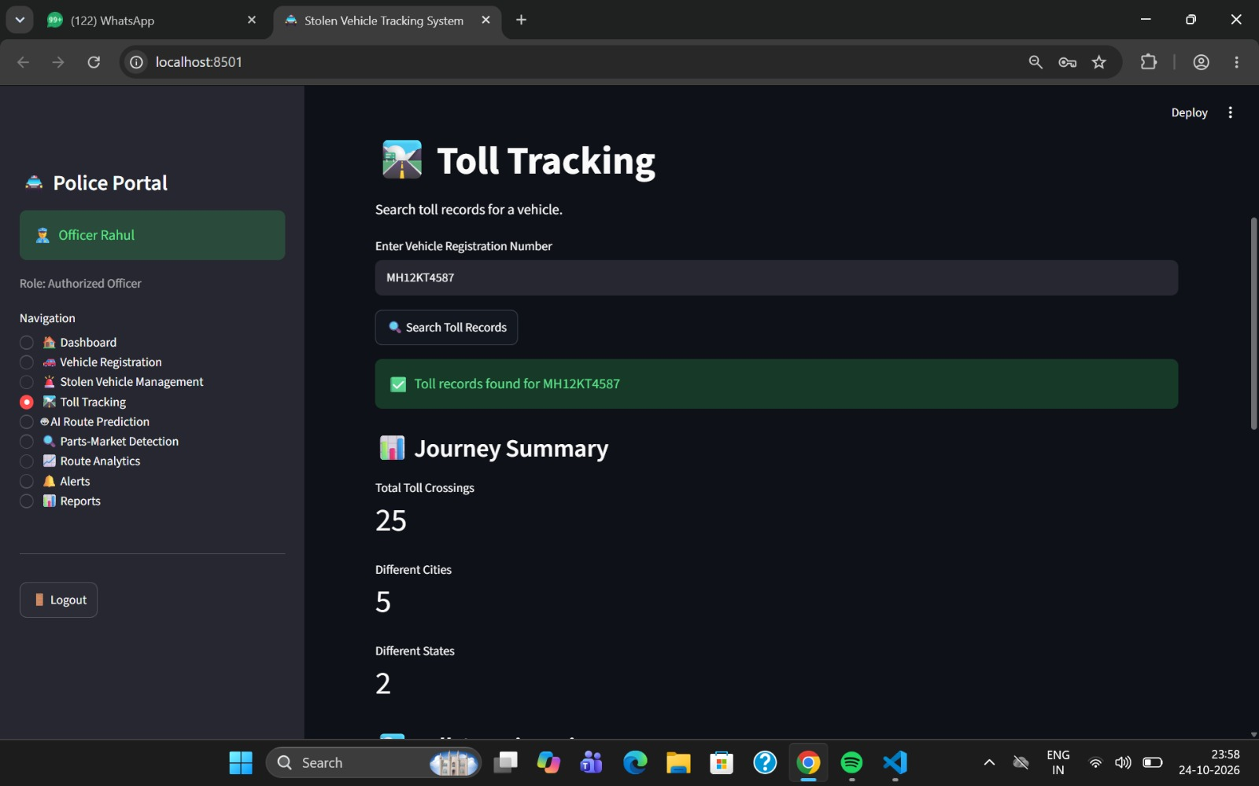

- Vehicle- route analysis
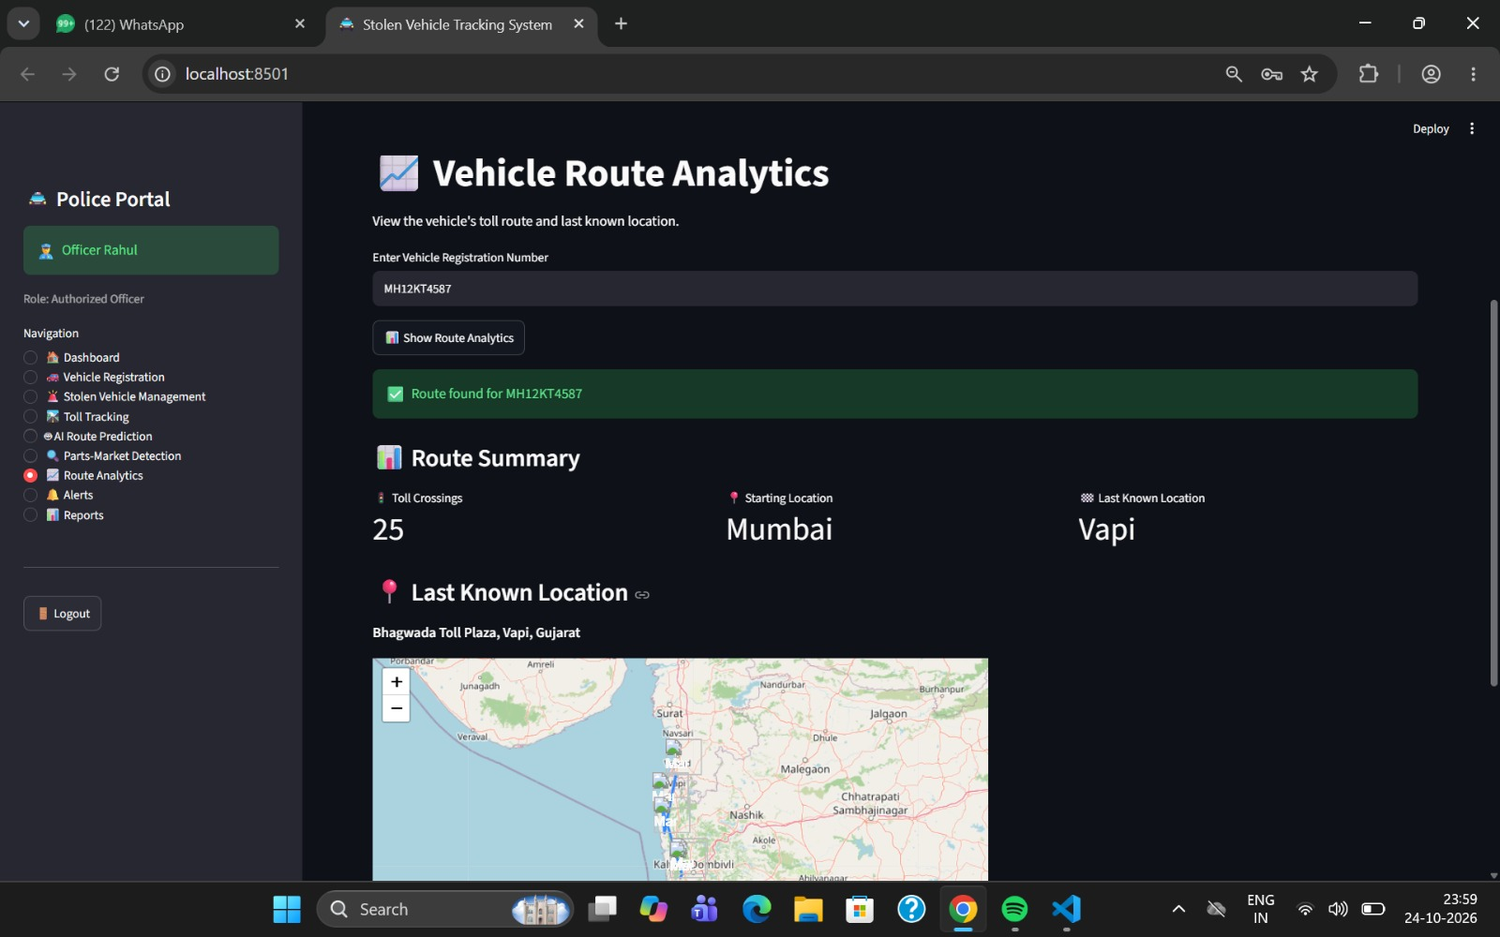

- Part - marketplace detection
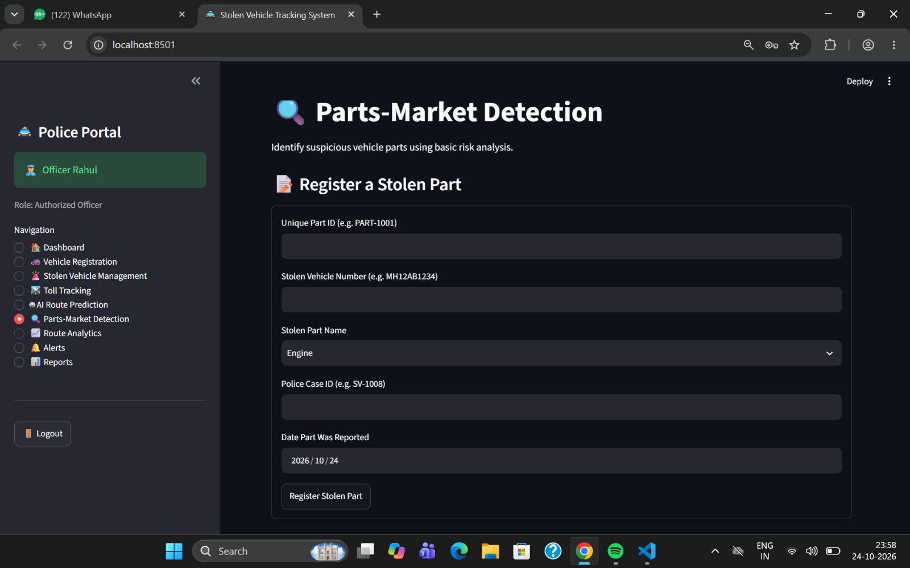

- Alert management
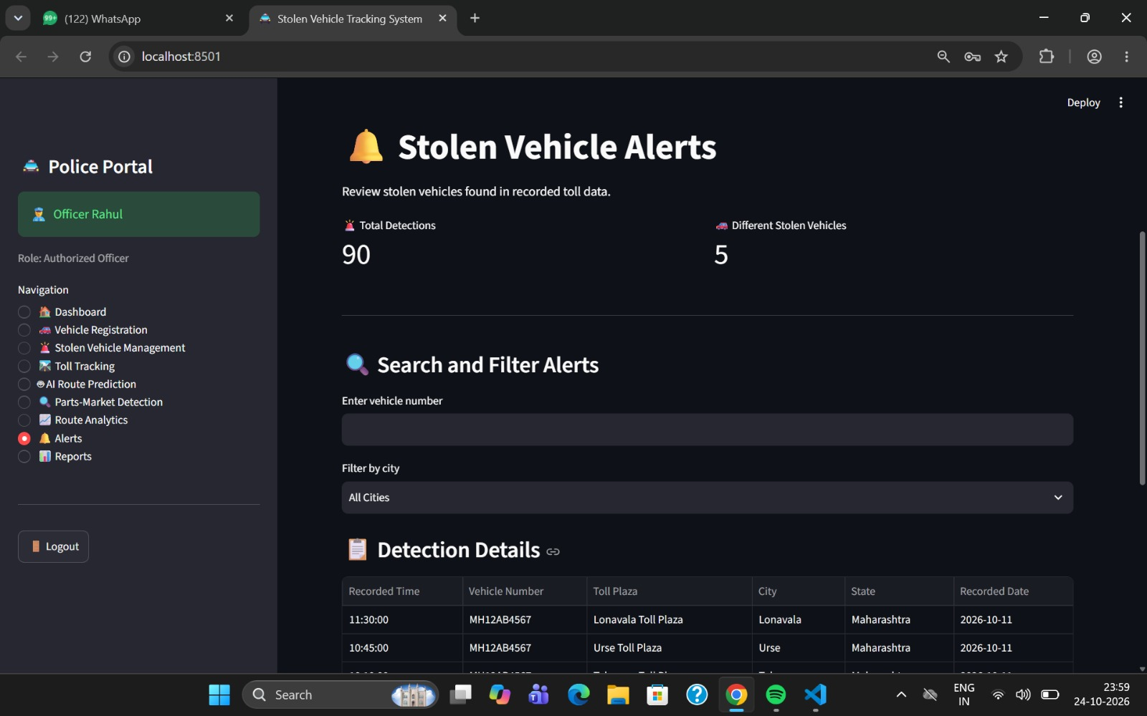

- Reports and audit logs
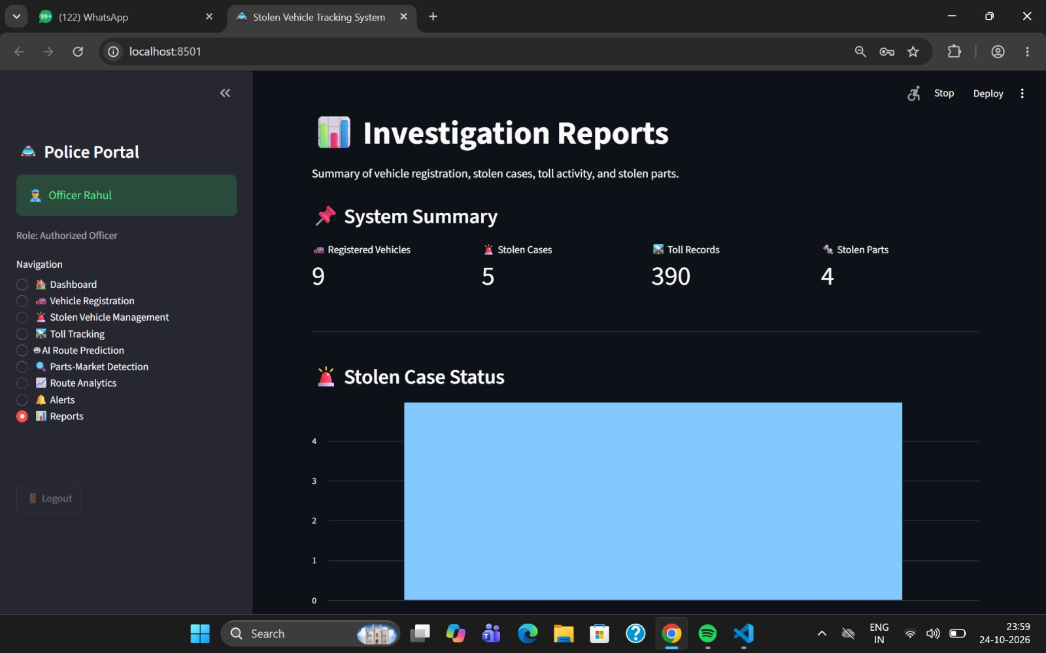
The dashboard presents information in tables, summary metrics, and charts where appropriate.
6.4 Backend Development
Python is used to implement the application's processing logic. The backend manages user requests, validates input, retrieves database records, executes matching rules, and invokes machine learning models.
The backend is divided into modules for vehicle management, stolen reports, toll processing, marketplace classification, alerts, and reporting. A modular structure makes the application easier to maintain and test.
6.5 Database Implementation
A database stores and organizes the information required by the application.
The main records include:
- Vehicle details
- Stolen vehicle reports
- Toll transactions
- Marketplace listings
- Prediction results
- Alerts
- User and audit information
Primary keys identify individual records, while foreign keys connect related records where supported by the database design. Validation rules help maintain data consistency.
6.6 Machine Learning Implementation
The project uses two main machine learning approaches.
1. Random Forest Classifier
The Random Forest Classifier estimates a possible next toll plaza from historical toll-sequence features. Its performance should be evaluated using held-out data and appropriate metrics, such as top-1 accuracy and top-k accuracy.
2. TF-IDF and Logistic Regression
TF-IDF converts marketplace listing descriptions into numerical features. Logistic Regression uses these features to classify listings into predefined categories.
Both models require suitable training data and testing. Their outputs should be presented as predictions rather than confirmed evidence.
6.7 Dashboard and Visualization
The dashboard provides a centralized view of the application's information. It can display vehicle records, toll transaction histories, predicted toll plazas, classified marketplace listings, and potential matches.
Tables, charts, filters, and summary indicators can help authorized users review information efficiently. Alerts should include sufficient context to explain why they were generated.
6.8 Security and Access Control
Security is important because the system may process sensitive vehicle and transaction information.
The main security measures include:
- User authentication.
- Secure password hashing.
- Role-based access control.
- Input validation.
- Restricted access to sensitive records.
- Audit logging of important activities.
- Appropriate handling of errors and confidential information.
The implemented security controls should be verified through testing before being described as fully operational.

CHAPTER 7 -
Testing and Result
Software testing is an important phase in the development of the AI-Based Stolen Vehicle Toll Tracking and Parts-Market Detection System. It is performed to verify that the developed system satisfies its functional and non-functional requirements and that its individual modules work correctly when integrated.
The proposed system combines conventional database operations with machine learning and natural language processing techniques. Therefore, testing must cover user authentication, vehicle registration, stolen vehicle reporting, toll transaction processing, next-toll prediction, marketplace listing classification, vehicle-part matching, alert generation, and report generation.
The main objective of testing is to identify errors, verify the accuracy of system operations, and evaluate the reliability of the implemented components. Testing should also confirm that invalid inputs are handled appropriately and that sensitive information is accessible only to authorized users.
The results of this chapter should be based on actual execution of the application. If synthetic datasets are used, the results must be clearly identified as synthetic-data results and must not be presented as evidence of performance in a real-world police or toll environment.
7.2 Objectives of Testing
The main objectives of testing are:
- To verify that users can log in using valid credentials and that invalid login attempts are rejected.
- To check whether vehicle records can be added, viewed, searched, and updated correctly.
- To verify that stolen vehicle reports are stored and their status can be updated.
- To evaluate the Random Forest model used for next-toll prediction.
- To evaluate the TF-IDF and Logistic Regression pipeline used for marketplace listing classification.
- To verify that potential matches generate appropriate alerts.
- To confirm that reports and dashboard information are displayed correctly.
- To identify errors, limitations, and areas requiring further improvement.
7.3 Testing Methodology
A systematic testing approach is required to evaluate the proposed system. The following testing methods can be used.
7.3.1 Unit Testing
Unit testing verifies individual components independently. Each module is tested with valid, invalid, and boundary inputs to ensure that it produces the expected output.
Examples include testing the login validation function, checking vehicle registration fields, verifying toll-data preprocessing, and testing the marketplace text-cleaning function.
7.3.2 Integration Testing
Integration testing checks whether different modules work together correctly. In this project, it includes testing the connection between the database and application, the flow from toll-data processing to stolen vehicle matching, and the process from marketplace classification to alert generation.
7.3.3 Functional Testing
Functional testing verifies whether the application performs the functions specified in the requirements. It focuses on the system's visible behavior rather than its internal implementation.
For example, when an authorized user registers a stolen vehicle, the record should be saved and should become available for subsequent searches and matching operations.
7.3.4 Machine Learning Model Testing
Machine learning testing evaluates the predictive and classification components using a separate test dataset that was not used to train the models.
- Random Forest Classifier: Evaluate the predicted next toll plaza against the actual next toll plaza.
- Logistic Regression classifier: Evaluate whether marketplace listings are classified correctly into the defined categories.
- Matching logic: Verify whether vehicle identifiers and relevant part attributes are compared according to the configured rules.
Model performance must be calculated from actual predictions and test labels. Expected behavior alone is not sufficient to establish model accuracy.
7.3.5 Security Testing
Security testing checks whether the application protects user accounts and restricts unauthorized operations. It includes checking invalid login attempts, role-based access, input validation, password storage, and access to sensitive vehicle information.
7.4 Functional Testing
Functional testing is used to verify the major features of the proposed system. Each test case contains a test ID, feature, input or action, expected result, and a field for the actual result.

The following test cases can be used during application testing.
Test ID | Feature Tested | Test Input / Action | Expected Result
TC-01 | User login | Enter valid credentials | User is authenticated and redirected to the appropriate dashboard.
TC-02 | Invalid login | Enter an incorrect password | Access is denied and an appropriate error message is displayed.
TC-03 | Vehicle registration | Enter valid vehicle details | Vehicle information is saved in the database.
TC-04 | Stolen vehicle reporting | Submit a valid stolen vehicle report | The report is stored with its status and reported date.
TC-05 | Vehicle search | Search using a registration number | The corresponding vehicle record is displayed if it exists.
TC-06 | Toll data import | Upload a correctly formatted toll dataset | The system validates and processes the records.
TC-07 | Toll matching | Process a toll record for a vehicle with an active stolen report | A potential match is identified according to the configured rules.
TC-08 | Next-toll prediction | Provide valid historical toll-sequence features | The Random Forest model returns a predicted next toll plaza or class.
TC-09 | Marketplace classification | Submit a marketplace listing for analysis | The NLP pipeline assigns a category or class according to its trained labels.
TC-10 | Vehicle-part matching | Compare a listing with a vehicle or stolen-part record | The system identifies a potential match when the configured attributes satisfy the matching rules.
TC-11 | Alert generation | Process a record that satisfies an alert rule | A corresponding alert is generated and stored.
TC-12 | Dashboard | Open the authorized dashboard | Available records, alerts, and summary information are displayed.
TC-13 | Report generation | Request a report for available records | The report contains the selected information in the supported format.
TC-14 | Audit logging | Perform an operation that is configured to be audited | The action is recorded in the audit log.
TC-15 | Input validation | Submit incomplete or incorrectly formatted data | The system rejects or flags the invalid input appropriately.

CHAPTER 8 -
Conclusion and Future Scope
This chapter presents the conclusion of the project, summarizes its major objectives and features, discusses its limitations, and identifies possible future enhancements.
The AI-Based Stolen Vehicle Toll Tracking and Parts-Market Detection System is proposed to support stolen vehicle investigations by combining vehicle record management, toll transaction analysis, machine learning, and marketplace listing classification in a centralized application.
The system uses a Random Forest Classifier to predict a possible next toll plaza from historical toll sequences and TF-IDF with Logistic Regression to classify marketplace listing descriptions. It also incorporates stolen vehicle matching, vehicle-part attribute comparison, alert generation, and reporting to help authorized users review potentially relevant information.
8.2 Conclusion
Vehicle theft is a serious issue that can cause financial loss and create challenges for vehicle owners and law enforcement agencies. Identifying the movement of a reported stolen vehicle and locating potentially relevant vehicle-part listings may require information from multiple sources.
The proposed project, AI-Based Stolen Vehicle Toll Tracking and Parts-Market Detection System, aims to address these challenges by integrating conventional database operations with machine learning and Natural Language Processing techniques.
The system is designed around three main data sources: vehicle records, toll transactions, and marketplace listings. These records are processed and analyzed to support vehicle identification, toll-sequence prediction, and marketplace listing classification.
The Random Forest Classifier is used to estimate a possible next toll plaza based on historical toll transaction sequences. This approach can help identify candidate toll plazas for further investigation. However, toll data provides observations at participating toll plazas rather than continuous geographical tracking.
The marketplace detection module uses TF-IDF to convert listing descriptions into numerical features and Logistic Regression to classify them into predefined categories. This can help organize listings and prioritize potentially relevant items for further examination.
The vehicle matching module compares toll transaction identifiers with active stolen vehicle reports. The vehicle-part matching module compares available attributes, such as make, model, and part name. The alert management component presents potential matches to authorized users for review.
The proposed application also includes a centralized database, dashboard, reporting functions, and audit logging. These components are intended to improve the organization, accessibility, and review of relevant records.
Overall, the project demonstrates how database management, machine learning, and NLP can be combined to support vehicle theft investigations. Its practical usefulness depends on data quality, model performance, appropriate authorization, and careful interpretation of the results. AI-generated predictions and potential matches should support human investigation rather than replace it.
8.3 Objectives Achieved
The project objectives and their implementation status should be documented according to the actual application.
Sr. No. | Objective | Description
1 | Vehicle record management | Maintain structured vehicle information.
2 | Stolen vehicle management | Record and update stolen vehicle reports.
3 | Toll transaction analysis | Process and organize toll records chronologically.
4 | Next-toll prediction | Apply a Random Forest Classifier to estimate a possible next toll plaza.
5 | Marketplace classification | Use TF-IDF and Logistic Regression to classify listing text.
6 | Vehicle-part matching | Compare available vehicle and listing attributes.
7 | Alert generation | Present potential matches for authorized review.
8 | Dashboard and reporting | Display records, predictions, alerts, and reports.
9 | Security and auditability | Apply appropriate access controls and record important activities.
Note: Mark an objective as achieved only after verifying that the corresponding functionality has been implemented and tested.
8.4 Major Contributions of the Project
8.4.1 Integration of Multiple Data Sources
The system brings vehicle records, toll transactions, and marketplace listings into one application. This design supports a more organized review process than handling each source separately.
8.4.2 Machine Learning-Based Next-Toll Prediction
The use of a Random Forest Classifier introduces a predictive component that learns patterns from historical toll sequences. The resulting predictions can be used to identify candidate toll plazas for further investigation.
8.4.3 NLP-Based Marketplace Classification
The combination of TF-IDF and Logistic Regression provides a practical method for processing listing descriptions and assigning them to predefined categories.
8.4.4 Automated Matching and Alerts
Rule-based vehicle matching and attribute comparison can reduce the effort required to identify potentially relevant records. Alerts help authorized users focus on records requiring additional review.
8.4.5 Centralized Dashboard
The dashboard provides a common interface for viewing vehicle information, toll records, predictions, classified listings, and alerts.
8.5 Limitations of the Project
Although the proposed system combines several useful technologies, it has limitations that must be considered.

8.5.1 Limited Availability of Real Data
Access to actual toll transaction records and verified stolen vehicle information may be restricted. Synthetic data can be used for development, but it may not fully represent real-world travel patterns.
8.5.2 Dependence on Data Quality
Missing vehicle identifiers, incorrect timestamps, duplicate transactions, and incomplete marketplace descriptions can reduce the reliability of matching and prediction.
8.5.3 Limitations of Toll-Based Tracking
Toll records indicate vehicle passage at specific toll plazas. They do not provide continuous vehicle location, and a vehicle may travel on roads without passing a recorded toll plaza.
8.5.4 Prediction Errors
The Random Forest Classifier may produce incorrect next-toll predictions, particularly when the available historical data is limited or travel patterns change.
8.5.5 Marketplace Classification Errors
The NLP model may incorrectly classify a listing because of ambiguous descriptions, spelling variations, unfamiliar terms, or insufficient training data.
8.5.6 Limited Attribute Matching
Marketplace listings may not include part numbers, verified vehicle details, or other attributes needed for reliable matching. Similarity between a listing and a vehicle does not establish that the item is stolen.
8.5.7 Privacy and Legal Constraints
Vehicle records, toll data, and marketplace information may be sensitive. Access, storage, and processing must comply with applicable laws, data-protection requirements, and source-platform terms.
8.5.8 Need for Human Verification
The system produces predictions and potential matches rather than definitive conclusions. Authorized personnel must verify relevant information before taking action.
8.6 Future Scope
The project can be enhanced in several ways to improve its functionality, scalability, and reliability.
8.6.1 Integration with Authorized Real-Time Toll Data
A future version could integrate with authorized toll data services to process new transactions more frequently. This could reduce the delay between receiving a toll record and presenting a relevant alert.
Such integration would require suitable permissions, reliable interfaces, and appropriate privacy safeguards.
8.6.2 Improved Next-Toll Prediction Models
The Random Forest Classifier could be compared with alternative models, such as Gradient Boosting or sequence-based models, if sufficient suitable data is available.
Future improvements could include:
- Using longer historical toll sequences.
- Incorporating time-of-day and day-of-week features.
- Accounting for time intervals between transactions.
- Using road-network information where available.
- Comparing top-k prediction performance across models.
- Monitoring performance as travel patterns change.
Any improved model should be evaluated on independent historical data before deployment.
8.6.3 Advanced NLP Techniques
The marketplace classification module could be enhanced using more advanced NLP approaches, including transformer-based text representations, if the dataset size and computational resources justify them.
These approaches may improve the handling of varied descriptions, abbreviations, and contextual language. Their effectiveness would need to be demonstrated through comparative testing.
8.6.4 Improved Vehicle-Part Matching
The matching module could incorporate additional attributes, such as verified part numbers, manufacturer details, model years, and component specifications.
Where authorized and appropriate, image-based analysis could also be explored to compare visible part characteristics. Such results would still require verification and should not independently determine ownership or legality.
8.6.5 Explainable AI
Future versions could provide clearer explanations for predictions and classifications. For example, the system could display the historical toll observations used for a prediction or highlight terms that contributed to a listing's classification.
Explainability would help users understand the system's output and identify possible errors.
8.6.6 Advanced Alert Prioritization
The alert module could be improved by ranking records according to transparent criteria, such as the strength of an exact identifier match, the availability of supporting information, and the model's evaluated performance.
The system should distinguish between confirmed database matches, model predictions, and unverified marketplace matches.
8.6.7 Cloud Deployment and Scalability
The application could be deployed on a secure cloud platform to support multiple authorized users and larger datasets. Future improvements could include stronger authentication, centralized monitoring, scheduled backups, and more scalable database services.
Deployment would require security testing and appropriate access controls.
8.6.8 Mobile-Friendly Interface
A responsive interface could allow authorized users to review records and alerts from mobile devices. This would improve accessibility where desktop access is inconvenient.
8.6.9 Improved Reporting and Analytics
Future reports could include historical toll-sequence summaries, model evaluation results, alert review statistics, and data-quality summaries.
These reports could help users assess the quality of the available data and monitor system performance over time.
8.6.10 Continuous Model Evaluation
Future versions could track model performance as new labeled data becomes available. Periodic retraining and evaluation may help address changes in toll patterns and marketplace language.
Model updates should be validated before being used in the application.
8.7 Expected Impact of the Project
The system is intended to support more organized vehicle theft investigations by bringing together multiple categories of information.
Its potential benefits include:
- Reducing manual effort in searching and comparing records.
- Helping identify toll transactions associated with active stolen reports.
- Providing candidate next toll plazas for further investigation.
- Prioritizing potentially relevant marketplace listings.
- Improving access to consolidated records and reports.
- Supporting review through structured alerts and audit logs.
These are expected benefits of the proposed design, not verified operational outcomes. Their actual impact depends on implementation quality, data availability, and evaluation results.
8.8 Final Conclusion
The AI-Based Stolen Vehicle Toll Tracking and Parts-Market Detection System presents an approach to combining conventional database management with machine learning and NLP for investigation support.
The project brings together vehicle registration management, stolen vehicle reporting, toll transaction processing, Random Forest-based next-toll prediction, TF-IDF and Logistic Regression-based marketplace classification, vehicle-part matching, alert generation, and reporting.
Its key strength is the integration of multiple analytical functions into one application. At the same time, its reliability depends on representative data, appropriate testing, secure access, and careful human review.
With further development, authorized data integration, improved model evaluation, and stronger matching techniques, the system could be extended into a more comprehensive investigation-support platform.
The project demonstrates the potential of AI-based data analysis to help organize and examine information related to stolen vehicles and potentially relevant vehicle-part listings.

CHAPTER 9 -
REFERENCES
[1] L. Breiman, “Random Forests,” Machine Learning, vol. 45, pp. 5–32, 2001.
[2] G. Salton and C. Buckley, “Term-weighting approaches in automatic text retrieval,” Information Processing & Management, vol. 24, no. 5, pp. 513–523, 1988.
[3] F. Pedregosa et al., “Scikit-learn: Machine Learning in Python,” Journal of Machine Learning Research, vol. 12, pp. 2825–2830, 2011.
[4] Python Software Foundation, “Python Documentation.” [Online]. Available: https://docs.python.org/3/
[5] Scikit-learn Developers, “Scikit-learn User Guide.” [Online]. Available: https://scikit-learn.org/stable/user_guide.html
[6] Streamlit, “Streamlit Documentation.” [Online]. Available: https://docs.streamlit.io/
[7] SQLite, “SQLite Documentation.” [Online]. Available: https://www.sqlite.org/docs.html
[8] F. Pedregosa et al., “Scikit-learn: Machine Learning in Python,” Journal of Machine Learning Research, vol. 12, pp. 2825–2830, 2011.
[9] A. Rajaraman and J. D. Ullman, Mining of Massive Datasets, Cambridge University Press, 2011. [Online]. Available: https://www.mmds.org/
[10] World Wide Web Consortium (W3C), “Web Content and Web Technologies.” [Online]. Available: https://www.w3.org/

CHAPTER 10 -
Appendices
APPENDIX A: SOURCE CODE
This appendix contains the important source code files developed for the AI-Based Stolen Vehicle Toll Tracking and Parts-Market Detection System.
The source code includes:
- User Authentication and Login Module
- Vehicle Registration Module
- Stolen Vehicle Management Module
- Toll Tracking Module
- Random Forest Next-Toll Prediction Module
- Marketplace Classification using TF-IDF and Logistic Regression
- Vehicle/Part Matching Module
- Alert Generation Module
- Dashboard and Report Generation Module
- Database Connectivity and Management
GitHub Repository: [Insert your GitHub repository link, if available]
APPENDIX B: ADDITIONAL SCREENSHOTS AND DATA TABLES
This appendix contains additional screenshots and sample datasets used to demonstrate the working of the proposed system.
The following screenshots are included:
- Police Investigation Dashboard
- Vehicle Registration Module
- Stolen Vehicle Management Module
- Toll Tracking Module
- AI Route Prediction Module
- Parts-Market Detection Module
- Vehicle Route Analytics
- Stolen Vehicle Alerts
- Investigation Reports
Sample data tables include vehicle records, stolen vehicle reports, toll transactions, marketplace listings, prediction results, and alert records.
APPENDIX C: WRITTEN RESEARCH PAPER
This appendix contains the research paper related to the project entitled:
"AI-Based Stolen Vehicle Toll Tracking and Parts-Market Detection System"
The paper describes the proposed system, its objectives, methodology, technologies, machine learning techniques, implementation, testing, results, and future scope.


